



AR Remote Rendering Application

Final Report



| **UCCS CE/ECE Senior Design Team**  Jack Brock  Amber Dolezal  Austin Hobbs  Amyleila Mejia  Stefano Signorelli | | **UCCS Project Sponsors**  William B. Micheal  Dr. Dana Wortman |
| --- | --- | --- |
|  |  |  |

Table of Contents

Executive Summary …………….……………………………………………………………. 3

Introduction ……………………………………………………. ……………………………… 3

Problem Description ………………………………………………………………………….. 4

Conceptual Design ……....…………………………………………………………………… 6

Final Design Description and Package ..…………………………………………………… 7

Testing Analysis Summary .………………………………………..……………………….. 24

Conclusion ……………………………………………………………………………………. 24

Project Planning and Project Management …..………………………………………….. 27

Sponsor Interactions ………………………………………………………………………… 29

Team Interactions …………………...……………………………………………………..… 30

Team Github Link ……………………………………………………………………………. 30

References …………………………………………………………………………………… 31

Appendix ……………………………………………………………………………………… 32

**Executive Summary**

Our task was to implement a program with an AR headset that ran on a separate computer, and streamed processed data back to the headset, as opposed to the entire program running on the headset. The purpose of this is mainly to increase the battery life of the headset, but other auxiliary advantages exist, such as running programs the headset doesn't have the computational power to handle.

Our chosen program is a blackjack helper, which provides the user with game statistics to help a novice+ win at blackjack.

While we have gotten most of our project working, object detection continues to give us difficulties, prohibiting us from providing a full demonstration of our product. Without this final key component, we are unable to fully fulfill the original requirements, and thus cannot meaningfully test for many of them, such as the improved battery life of the device.

**Introduction**

Dr. Omid Semiari’s research interests include wireless communications, machine learning, cross-layer network optimization, signal processing, and context-aware networks with an emphasis on new technologies such as connected and autonomous vehicles, wireless extended reality, and industrial IoT. Recently, he has collaborated with students and alumni in MINDS LAB to conduct research on ultra-reliable low-latency communications, machine learning and communications, millimeter wave and terahertz communications, context-aware networks, autonomous vehicles and platoons, and wireless extended realities. Well within his research interests Dr. Semiari has requested to start pursuing a new project with this year’s ECE Senior Design Team, to design cutting-edge communication that would enable an AR/VR device to utilize a host computer for its processing. Such an upgrade will further the team’s efforts to focus on remote rendering, in an attempt to decrease battery consumption and increase memory availability.

However, before the start of the fall semester Dr. Omid Semiari left the University of Colorado, Colorado Springs to pursue another job. Due to this, our team knew we needed to get another sponsor that had skills that would pertain to this project. After several discussions amongst the team, we decided to reach out to Dr. Dana Wortman. Dr. Wortman is currently a senior instructor in Game Design and Development and also conducts research in Graphics and Information Visualization. Since our team had little to no experience with game development or utilizing Unity we thought her skills would be extremely helpful to our team and the remainder of this project.

In order to design a system according to Dr. Omid Semiari’s requests we decided our project would use a HoloLens 1 for AR capabilities and Unity for our game development and deployment. As a team we came up with the idea to design an AR Blackjack Assistant application to use as a test to show that our project did indeed decrease battery consumption and increase memory availability.

**Problem Description**

Originally, the issue to be solved was a wireless communication & power consumption problem. We have an AR device (the Microsoft HoloLens) and we wanted to improve the runtime & battery life by rendering our game of choice on the host computer wirelessly. Ideally, since the rendering will not be done on the hololens, we expected an improvement. The following lists our current requirements.

**Project Requirements**

The following is a list, in order of importance according to the sponsors, requiring the remote rendering device to:

* accompany a set of documents specifying every piece of software and its functionality
* allow the AR/VR device will connect to a wifi-router in order to communicate to the host computer
* perform the app rendering and processing will be done on the host computer
* improve runtime and battery life
* allow the app rendering and processing will be done on the host computer
* identify the playing cards that a person is holding
* determine the value of the cards that are given to the player
* determine the value of the cards held by the dealer
* display the value of the cards that are on the table
* display the statistics for next move that the player should perform
* determine if the player should hit, split, or stand for their next move

**Parameters and Target Values**

To ensure each of the project requirements are met, verifiable engineering parameters and accompanying target values are identified as follows. This remote rendering device will:

* be implemented using a HoloLens
* have a total system latency will be under two seconds
* improve battery life by at least TBD
* display the probability of success for each move the player could perform
* display a graphic and play a sound when player hits a card count of twenty-one
* play a sound when player wins the game

For this project, the object detection was done separately from the game logic. We successfully got object detection working correctly & the game logic to successfully read the probabilities from the game logic script in Unity. Here, we’ll go over what requirements we were able to get done, and what we didn’t get to.

**Completions**

* *The AR/VR device will connect to a Wi-Fi router in order to communicate to the host computer* ▶ We successfully connected the HoloLens to our provided router and successfully setup communication (outside of a game)
* Determine if the player should hit, split, or stand for their next move ▶ In our Unity game, we successfully were able to detect what should happen next via the probability script. The UI renders correctly, and successfully updates the on screen probabilities with a given set of dealer & player cards.
* Determine the value of the cards held by the dealer ▶ YOLO was able to successfully identify playing cards, however once integrated, the code would need to differentiate cards held by the dealer from cards held by the player.
* Display the probability of success for each move the player could perform ▶ This is done via the probability script, and is successfully printed to the screen.
* Display a graphic when player hits a card count of twenty-one ▶ An overlay (coins) was made to show when a player hits 21 or wins.
* Display the statistics for next move that the player should perform ▶ Statistics are handled through the probability script.
* Play a sound when player wins the game ▶ After a lot of messing about with Unity, we finally got sound to play correctly when a player wins.
* Identify the playing cards that a person is holding ▶ YOLO successfully identifies cards in the webcam scene.
* Determine the value of the cards that are given to the player ▶ YOLO outputs the value it sees of each card it successfully identifies.
* Display the value of the cards that are on the table ▶ YOLO identified the cards on the table if a webcam is situated above the table.
* Accompany a set of documents specifying every piece of software and its functionality ▶ Documents were created (here with this Final document) and on GitHub outlining our current work.

**Failures**

* Implemented using a HoloLens ▶ We unfortunately could not get the integration between all parts to work as one unit, so this was not able to be implemented on the HoloLens.
* Total system latency will be under two seconds ▶ In this case this requirement fails since the system is no longer on the HoloLens itself.
* Improve runtime and battery life ▶ In this case this requirement fails since the system is no longer on the HoloLens itself.
* Perform the app rendering and processing on a host computer ▶ In this case this requirement fails since the system is no longer on the HoloLens itself.

From above, we found ~73.33% of the requirements were met.

**Conceptual Design**

Originally there was a Python Transmission Control Protocol, TCP, that was to be used for game rendering in Unity. After having issues with the weight file conversions the team did not follow through with this original plan and instead progressed towards the preparation of two demonstration models instead. This would allow the team to showcase the working parts of the project. Not implementing the use of the Python TCP did not satisfy the following requirements:

* Implemented using a HoloLens
* Total system latency will be under two seconds
* Improve runtime and battery life
* Perform the app rendering and processing on a host computer

We ended up not using the Python TCP Server since it added complexity that was not strictly necessary with the project. We found a solution simply by using the command prompt to start the game. An emulator was used to model what the Hololens was to render. This was used in the demonstration involving the Hololens.

The conceptual design proposed the use of the YOLO algorithm version 2, YOLOv2. The final version that was used for the project was YOLOv4 due to software compatibility issues. This led to a change in the neural network implementation software to the use of Barracuda which was not originally in the specifications but it was the only software that allowed the implementation of the Darknet neural network and was compatible with Unity.

Committing to the use of Unity into the finalizing phase of this project allowed for the development of a proper special effects and game logic demonstration as well as a demonstration for the proper use of the algorithm. The main reason for committing to Unity was for the compatibility that YOLO had with Unity.

The game logic class was created within Unity methods start and update, modeling classic Black Jack game rules. The game logic design was implemented using C# as originally stated in the requirements. A python script called “blackjack.py” was used to calculate the probabilities of winning when the player chooses “hit” or a “stay” for each round of blackjack. The Python script would write to a text file with the probabilities, and the main GameLogic.cs C# script would read the text file and then update the UI. The “GameLogic.cs” script would also launch the python script using the command prompt. Objects in Unity could be rendered as graphics with their own script components. The “GameLogic” object has the “GameLogic.cs” script attached as a component.

**Final Design Description and Package**

**Description**

For the final design, an attempt to integrate both the Microsoft Hololens V1 and YOLO has failed. The development of the program has achieved a trained AI which is capable of detecting playing cards, and a working app that updates a user interface(UI) with the probability statistics for each round of blackjack.

Game Logic

While the full implementation of the Microsoft Hololens and YOLO with Unity Editor has not been achieved, the trained AI works correctly when using darkent, and the game logic on the unity editor works as well. This can be seen when launching the app on the Unity Editor, when pressing play, the user interface (UI) on the top-left will update the probabilities of winning when performing a “hit” or a “stay” in blackjack. It will update the probabilities for each time the player and the dealer have “hit” to gain a new card in blackjack. The game logic would not have done anything outside modeling this because it is based on the classical game rules of Black Jack.

Graphics: Probability & Statistics

To have the probability statistics functionality to work on the user interface (UI), there are many steps in the C# script to get this to work. Firstly, in the GameLogic.cs C# script, hardcoded values for each hand of the player and the dealer are obtained and added to a global list. This list starts with “p” to signify the following values are the player’s hand, and then has “d” to signal that the following values are the dealer's hand. After the list is hardcoded with values, the program iterates through the list, and adds the values as it iterates through the list for each round of blackjack. This is because the C# script will call a python script called “blackjack.py” shortly after where it uses the sum of the dealer and player’s hand to calculate the probability for the player to win when performing a “hit” or a “stay”. This is demonstrated as a graphic in the game with a correlating percentage value.

To run the python script, a process will be started to run a command on the command prompt which will execute the blackjack.py with Python. Because this program uses command prompt, this app/game will not work for computers that run an iOs or Linux operating systems. To create this process, the System.Diagnostics package has to be included at the top of the C# script. With this package a process can be made that executes the commands needed on the command prompt. First a command is run to go to the assets directory of the Unity project where “blackjack.py” is located. Then another command is run to execute the python script with python, to do this the full path of where python is installed in the host computer must be specified. Additionally, this command is executed with the values from the player’s and dealer’s hand as command line input arguments, it includes the “p” and “d” characters to differentiate whose card values are whose.

Once the “blackjack.py” executes, it goes through many mathematical parts to calculate the corresponding probability with respect to the player and dealer’s hands from the command line input arguments. Once the probabilities are obtained, the python script writes to a text file the probability results for winning when performing “hit” and “stay” for the player. The text file it writes to is called “probs.txt”. After executing the python script, the C# script “GameLogic.cs” reads the “probs.txt” file to obtain the probabilities needed to update the user interface (UI) with the correct probabilities.

To update the UI, the “GameLogic.cs” C# script can reference game objects created in Unity Editor by their name given. So for the UI portion, there are two “TMP_Pro - Text” game objects which are responsible for creating the text to display the probabilities. The gray background, and the square dimension is created with the “Panel” and “Canvas” game objects which are parents to the two “TMP_Pro - Text”. The two “TMP_Pro - Text” are named “ToHit” and “ToStay”. These game objects can be seen in the the left hand side of the screen in the Unity Editor. All the game objects present make the “scene” in unity, and these game objects can be attached with C# script to run code. The “GameLogic.cs” C# script is attached to the “GameLogic” object. Once the “ToHit” and “ToStay” game objects are referenced, the text can be updated by setting its “.text” data member to a string. The string would be the probability results read from the “probs.txt” file.

Blackjack Assistant Instructions

1. Download the zip, or fork the Github repository from the main branch at: [https://github.com/uccsAR-VR/AR-Annihilators/](https://github.com/uccsAR-VR/AR-Annihilators/tree/CurrentGame) to obtain the unity project folder.
2. Launch the unity project with the Unity Editor via Unity Hub by specifying the folder location. Launch the project with Unity Editor version: 2020.3.35f1.
3. With the Unity Project open, go to the Assets folder and open the “GameLogic.cs” file with any IDE to update the full assets folder path where blackjack.py is located. When specifying the full path in the code, you must use double backslash: “\\”. Where this full path is needed to change is in line “169” of “GameLogic.cs''.
4. After loading the project and the changes has been made, you can click play on the upper part of the screen to launch the blackjack assist.

Object Detection for the HoloLens Project

# *Background*

## PROJECT FLOW

The original goal of this project was to create a game that can be run on the computer & the Microsoft HoloLens to measure a difference in playtime and to see a runtime improvement. The game we chose was a statistical overlay for blackjack which would detect playing cards using a variant of the YOLO (You Only Look Once) machine learning object detection algorithm and then display statistics for the next move. A GitHub repository [1] containing a Jupyter Notebook for training the playing cards was used. The repository was responsible for obtaining & formatting the data needed to initialize training on the darknet network [2]. More on Training in the next section.

At the start, we decided on YOLOv2 because of its compatibility with Unity 2019 (Unity version required for the HoloLens 1) and the need for an ONNX file. We found an existing repository [3] which handles YOLOv2-tiny ONNX files and running interference[1] on them. In order for the YOLOv2 repository to work for our needs, we need to have it detect playing cards. This is done by loading a trained ONNX file into the project. However, we could not convert the darknet WEIGHTS file into an ONNX file. To convert from a YOLOv2 WEIGHTS file to ONNX, we used this repository [4] but due to software versioning issues (the tool was made in 2017), this did not produce a result. With research, no other tools seemed to exist for the YOLOv2 conversion. We then decided to try YOLOv4. YOLOv4 was trained with the built-in darknet network successfully. The resulting WEIGHTS file was converted to ONNX via another tool [6]. This conversion was successful and a valid ONNX file was converted.

Once we had a valid (or so we thought) ONNX file, we then used this file in this repository [5] to load the ONNX file into Unity. Unity recognized the file, but gave errors saying the array sizes do not match. We thought this could be because the ONNX file was not created correctly, this assumption turned out to be true, and we had to stop the project here. Using an ONNX analyzer tool, we found out that the output vector was not the same as the output vector in the accompanying WEIGHTS file.

## ONNX

ONNX stands for Open Neural Network Exchange, which is a neural network model in a convenient all-in-one file to interface between different programs (Unity in our case). There are multiple ways to convert the WEIGHTS file into an ONNX file for use with Unity. You can use PyTorch[2] and convert the model to a PyTorch model, then directly to an ONNX file. Another option is to use different framework, like OpenCL

# Training

The Jupyter notebook used for training, called creating-playing-cards-dataset, was extremely helpful in creating the dataset needed. First, a video of each card was created with varying levels of exposure. This was to give more variance to the dataset and increase accuracy. Once the videos were taken, they were loaded into the notebook which cuts out the card from its background, draws a bounding box around the card number, and then superimposes them with other cards onto a generated background to create a “scene”. These scenes were then converted from the Pascal VOC format to xml & text files for use as inputs to the darknet network for training. 

One issue we had was getting the cutout algorithm to recognize the cards, the solution was to increase the lighting by a factor of 2x to get the desired result. Another issue we had was creating bounding boxes for the face cards (King, Queen, Jack), we believe the algorithm did not work well with the box surrounding the card itself (shown here in Figure with the red arrow). Solution for that was to continually take more videos until the bounding box algorithm found the boxes (this took a while, but we eventually got some results).

Once we had the dataset that darknet expects, we moved onto training on the network from the generated scenes. At first, we used YOLOv2 but due to some issues, we ended up training fully on YOLOv4. For YOLOv4, you need the following information to train:

* A custom configuration (.cfg) as a base to start with, modified according to AlexeyAB [2].
* An obj.names file containing the location of the scene files with <object-class> <x_center> <y_center> <width> <height> outlining the locations of the bounding boxes.
* An obj.data file containing the location of the names file & how many classes.

Training is started using ./darknet detector train data/obj.data yolo-obj.cfg yolov4-tiny.conv.137, which will train on your GPU. After 100 iterations, you want to change the command to use your created WEIGHTS file instead of yolo4-tiny.conv.137 so that the darknet training program can calculate the mAP & average loss when training.

# Future for the Project

This project was interesting and had a lot of challenges. I’d say in the future, we need to get the integration between the HoloLens & the game logic program in Unity for the project to be fully successful. Ideally, a set of group members to possibly take on this project should:

* Successfully output an ONNX file for use in Unity.
* In Unity, recognize playing cards from the ONNX model.
* Integrate the object recognition code [5] and our blackjack statistics project
* Run the game on the hololens.
* Perform testing to see if the project saves battery life.

**Package**

# Object Detection Instructions

Currently, the detection works via a webcam & the built-in darknet detector demo [2]. This demo runs interference on the input webcam frames, and then draws bounding boxes on the output video feed frames. Prerequisites for the demo:

* Darknet [2] must be compiled.
* A trained weights file must be generated.
* A webcam is preferred but the detection does work on static images.

To run the demo:

1. Plug in the webcam into the host computer.
2. Position the webcam vertically above the cards to be detected and make sure the scene has plenty of light.
3. Navigate to the darknet folder containing the build files.
4. Run the following command from windows PowerShell:

**darknet** detector demo .\data\obj.data .\cfg\yolov4-tiny-obj3.cfg .\backup\yolov4-tiny-obj3_20000.weights -c 0

**.\data\obj.data** → location of the custom object data file.

**.\cfg\yolov4-tiny-obj3.cfg** → location of the custom object configuration file.

**.\backup\yolov4-tiny-obj3_20000.weights** → location of the trained WEIGHTS file.

**-c 0** → Use system webcam with ID=0

1. Observe the output in the video feed window with the bounding boxes drawn on. The identified cards will also appear in the command line window.

Compilation of GameLogic.cs and Launch

The compilation of code in the Unity project is done automatically if changes are made to the file. The only change that would be performed is if a new computer is being used, and the path to the blackjack.py file needs to be specified in the “GameLogic.cs” C# script. If not doing this change, there is no need to compile anything, it should be ready to launch when pressing the start/stop button on the Unity Editor after opening the project folder through “Unity Hub”. When the game runs, it will launch the Python script continuously. No compilation needs to be done for Python since it was compiled once to get it functioning.

Bill of materials

* Microsoft Hololens (1st gen) ($810 new on Ebay plus $30 for shipping)
* WiFi 6 Netgear AX1800 Wireless Access Point ($40 new on Amazon)
* Playing Card with Chips ($7 new on Amazon)
* Total price for needed items is $887
* Total budget is $1000 to cover tax when purchasing.

Note:

The final design as of now does not have the full Microsoft Hololens implementation working, but it is listed here because it was intended to be a part of the final project solution.

| **Item** | **Cost** |
| --- | --- |
| Microsoft HoloLens | $810 |
| AX1800 Dual Band Wireless Router | $40 |
| Deck of Cards Bicycle Brand | $3.50 |
| **Total** | $853.50 |

UML Diagrams

Unity Project: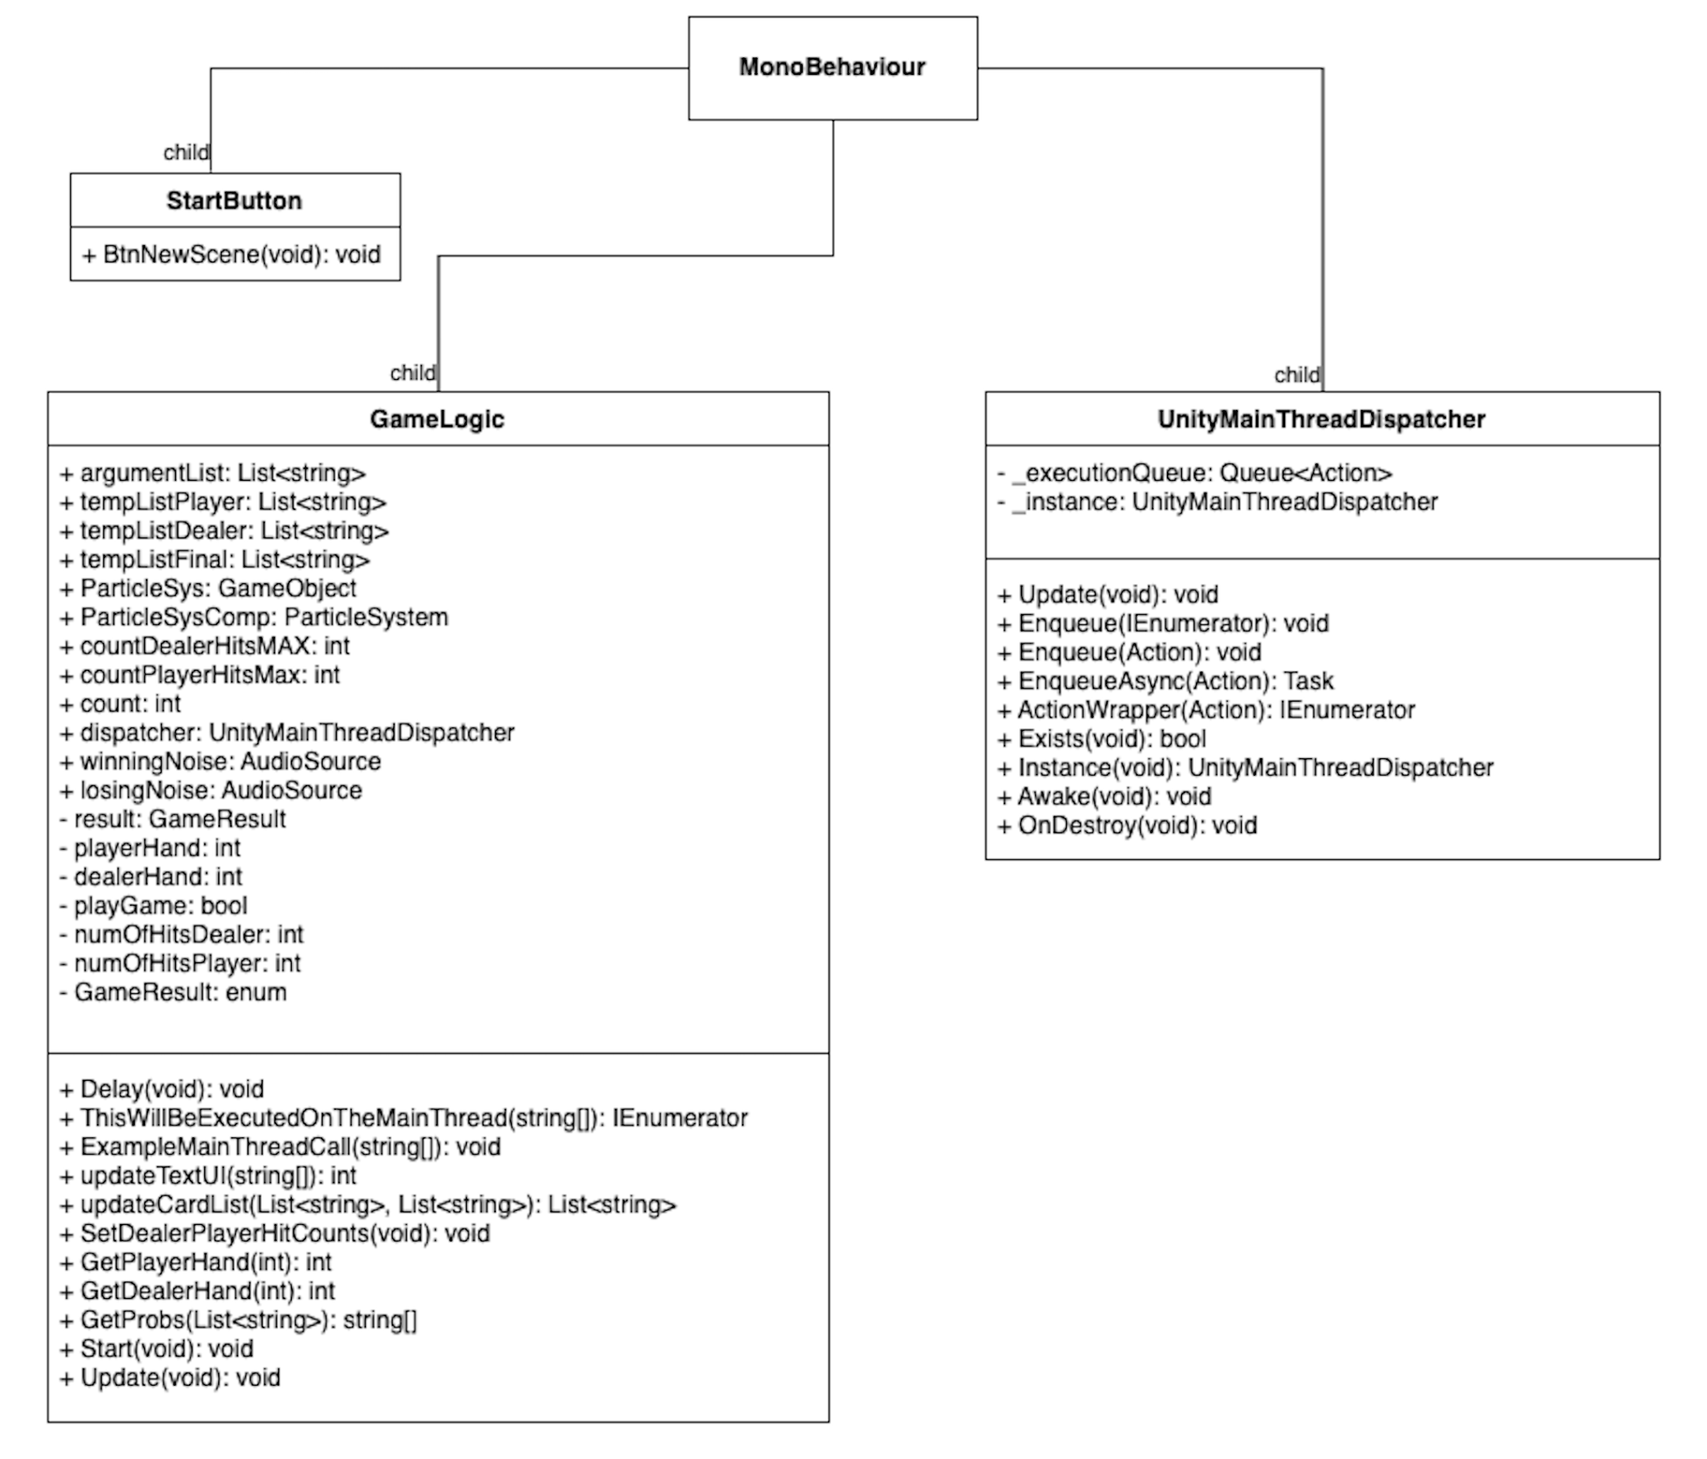

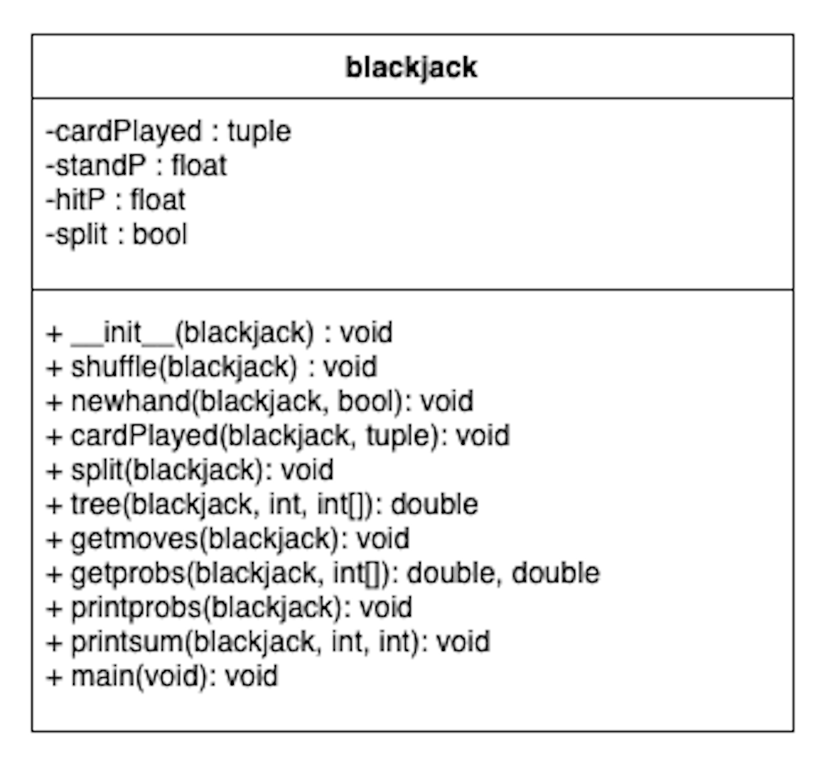

Object Detection:

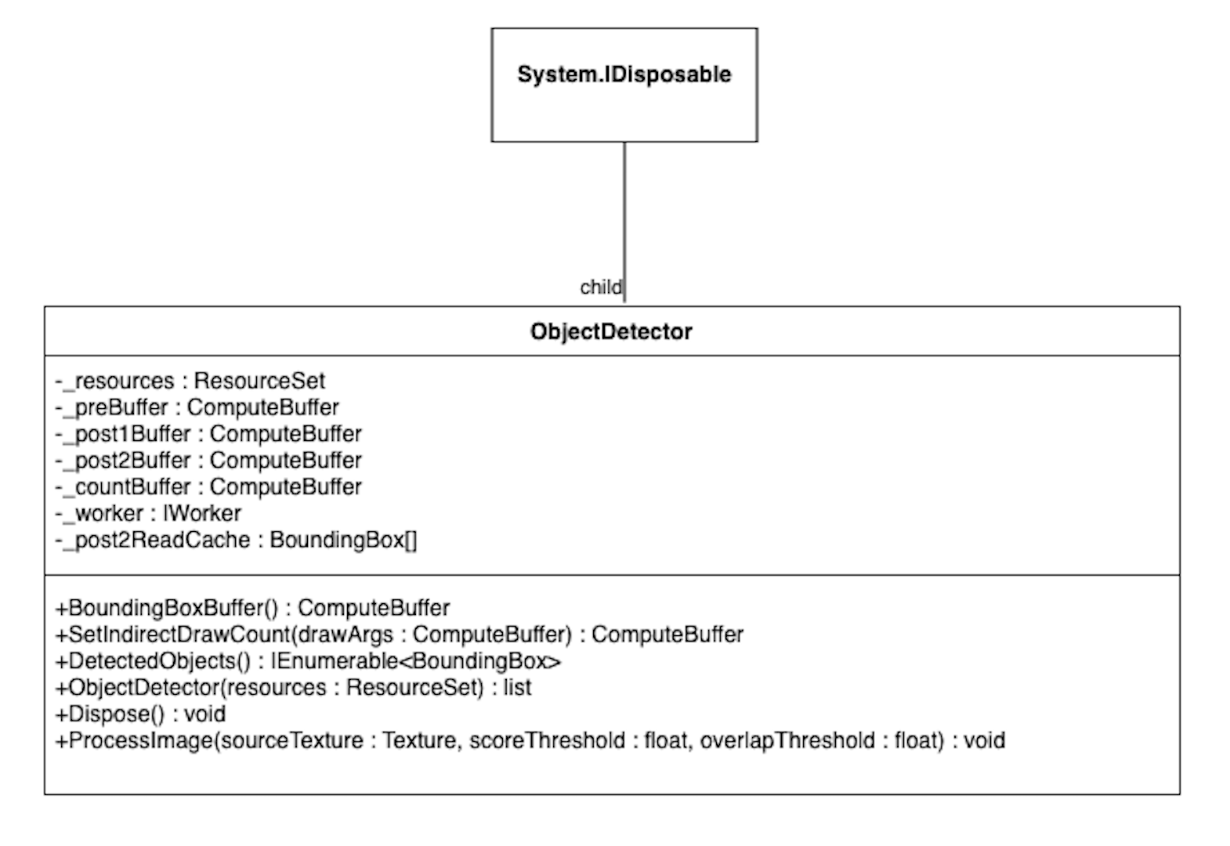

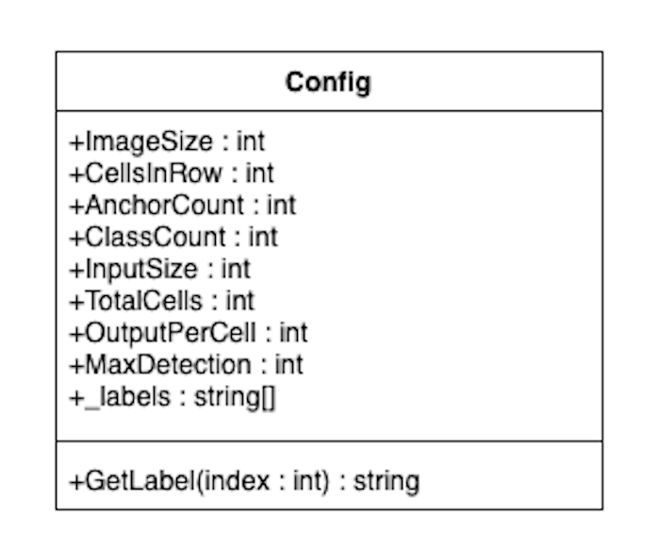

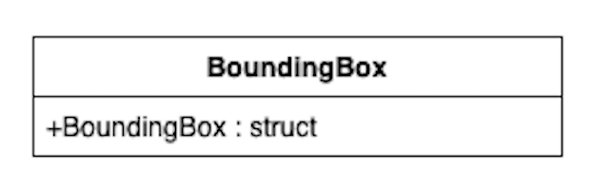

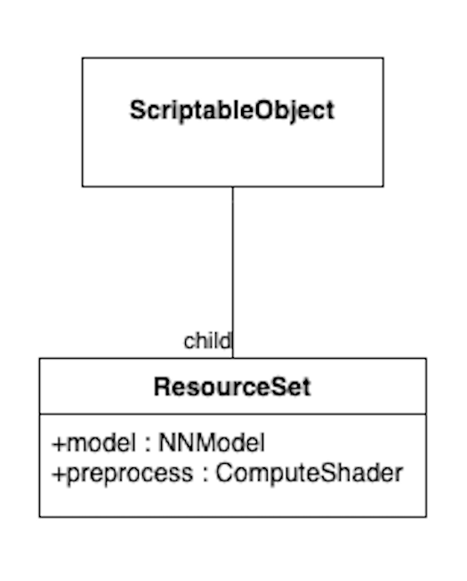

**User Manuals and Instructions**

# Maintenance Instructions

For troubleshooting the HoloLens the Microsoft Ignite Documentation Online is a great source to reference. This documentation remains up to date on issues any owner of the HoloLens has faced, along with a detailed description on what to do in these situations. This information can be found at: [HoloLens (1st gen) hardware | Microsoft Learn](https://learn.microsoft.com/en-us/hololens/hololens1-hardware). This resource will also be extremely useful for users because it contains user instructions and provides links to online communities that can help with any problems that might come up.

# Parts and Materials

1. HoloLens Generation 1

### 

Figure 1: HoloLens 1 Components

1. Router
2. Cables used for Router
3. Host Computer
4. 2 Handheld Remotes

# Instructions

# 1.)Turn ON

1. First place the HoloLens 1 on your head, ensuring that the device is properly sitting in place and not loose. An unsecured headset could end in injury or damage to the device. Please see figure 2 for more information on HoloLens adjustment methods.
2. To turn on the HoloLens Gen 1 there is a button located on the back of the headset (see figure 3). Hold this button down for four seconds.
3. Turning on the device also requires turning on the app for full interaction.
4. Open the project file in the host computer. The icon the user will need to find on the host computer desktop can be referenced in figure 3.
5. The user will enable and launch the app, figure 3, by interacting with the Unity Game Engine and double clicking on the app icon.

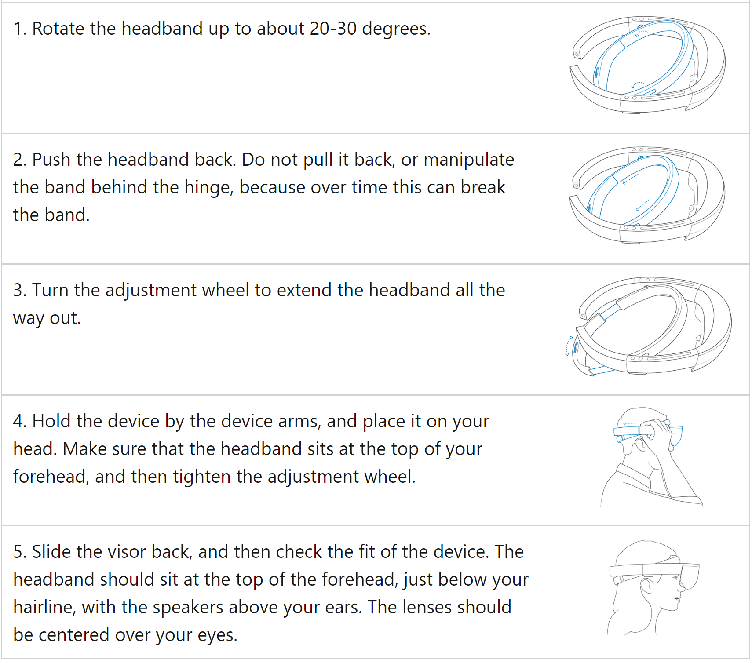

### Figure 2: HoloLens proper adjustment methods and handling.

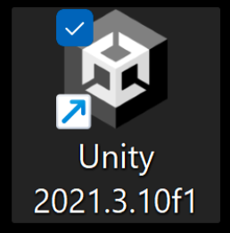

Figure 3: Desktop version of the Unity Game Engine Launcher

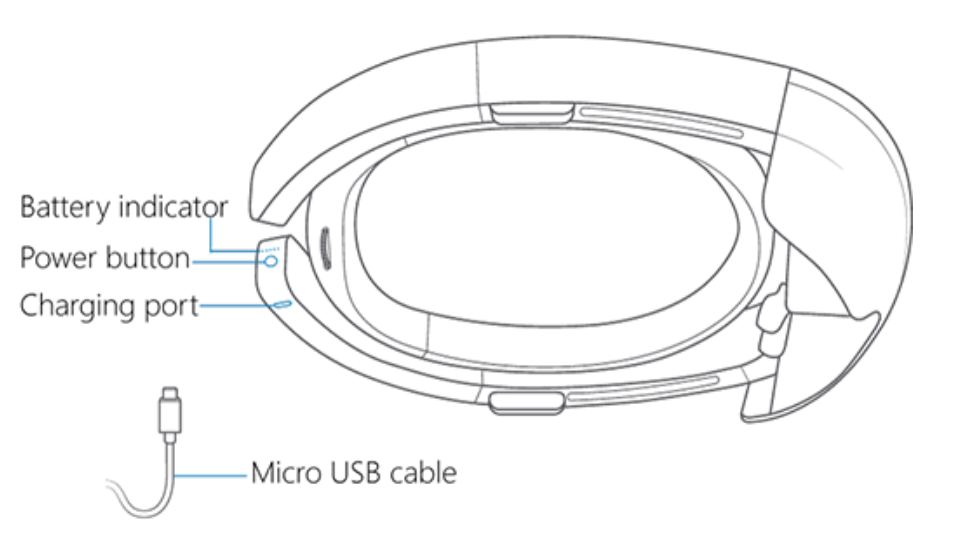

### Figure 4: Power device overview. Charging and button locations can be clearly seen.

# 2.) Brightness and Volume Adjustment

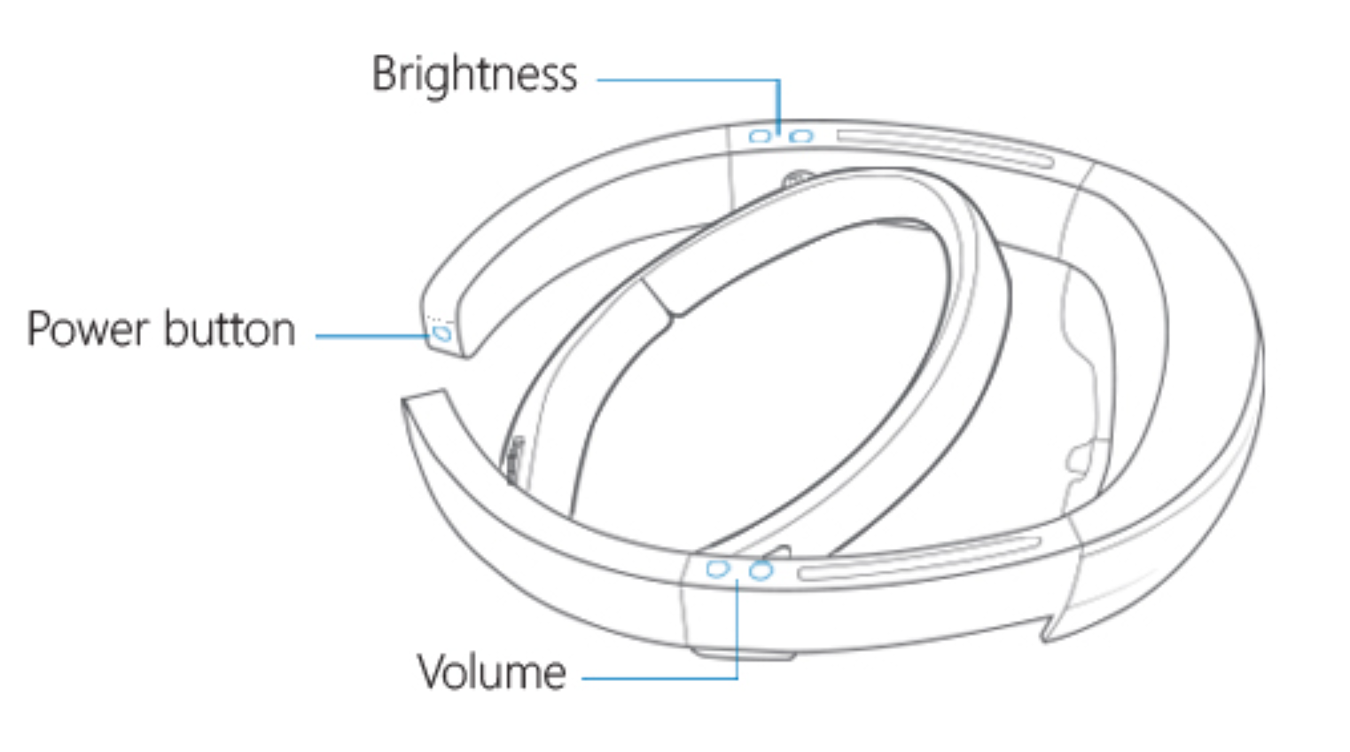

Figure 5: Power, Volume, and Brightness adjustment placement

# 3.) Unity Game Engine Project Selection

1. Once the user double clicks the app icon the project drop down menu will be opened in the Unity Game Engine and can be referenced in figure 6.
2. The user will then proceed to go to the drop down menu under the projects file, figure 5, and find the corresponding project to select. This will open up that project. The example from figure 5 is the folder my_first_unity.

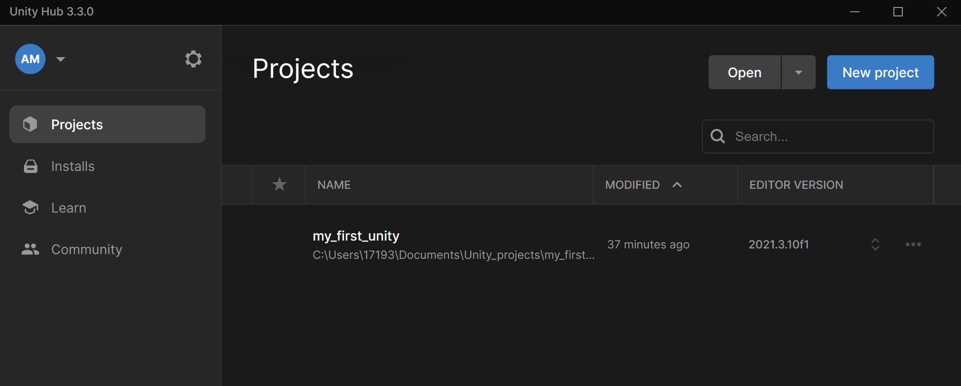

Figure 6: Unity Game Engine list of projects

# 4.) Unity Game Engine Build Settings

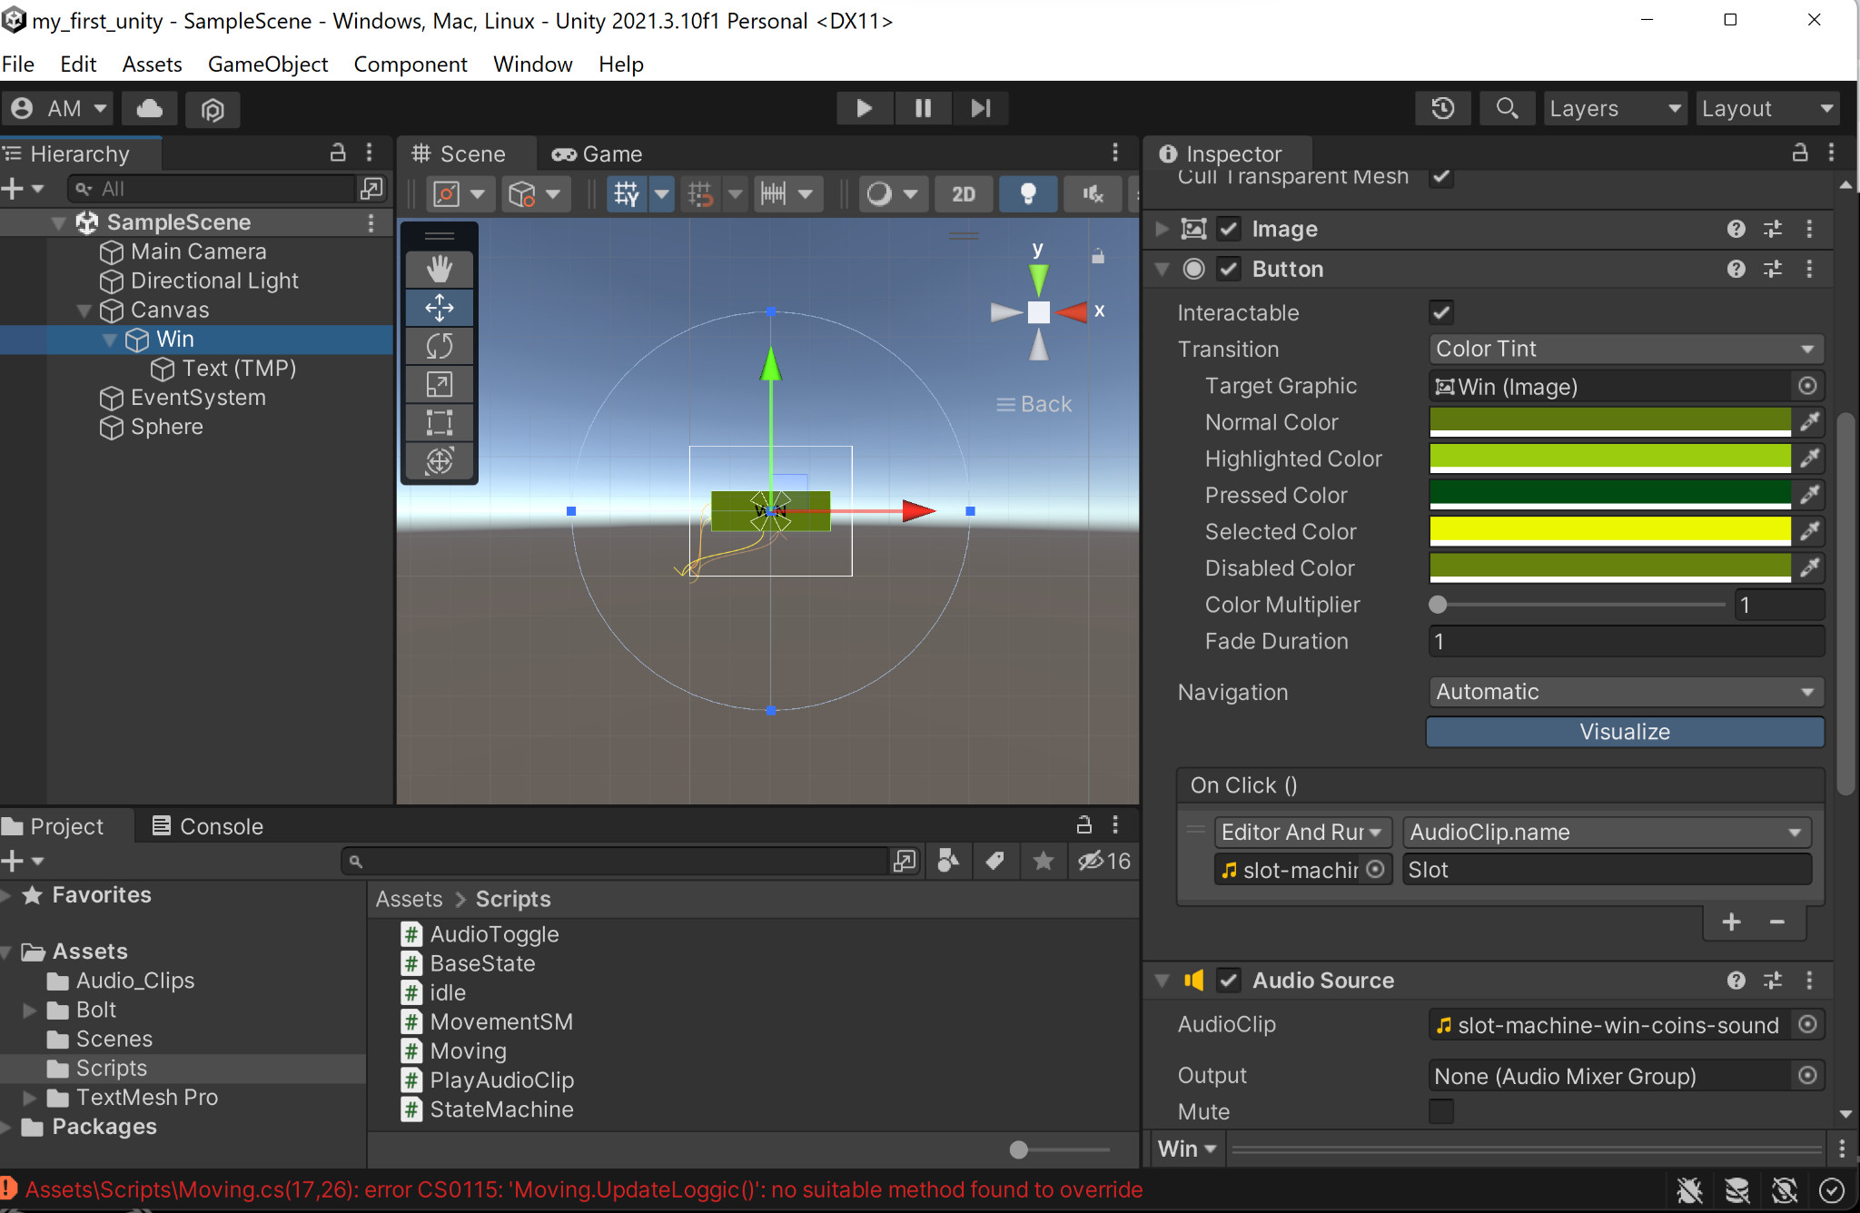

Figure 7: Unity Game Engine Project opened

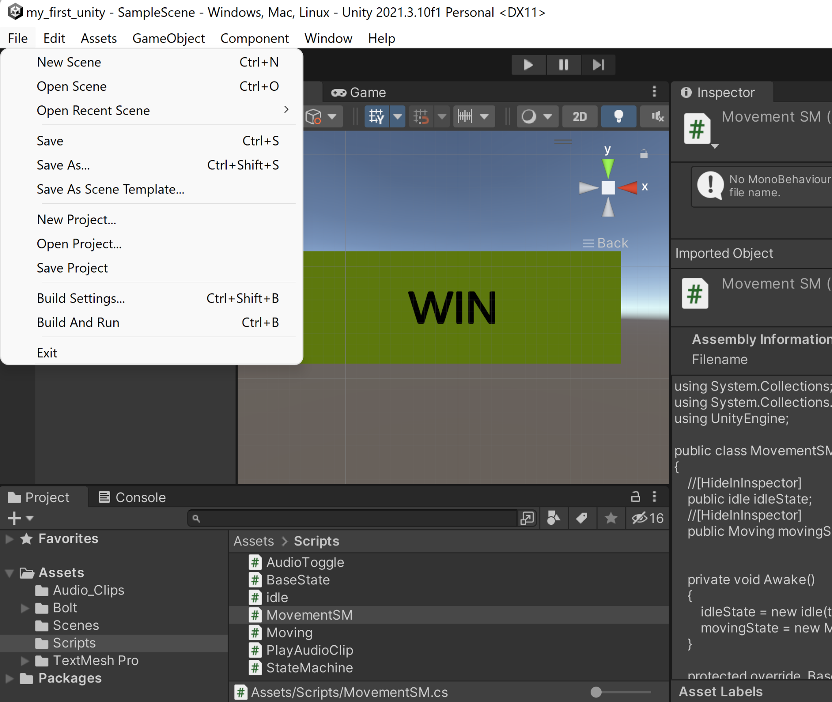

Figure 8: Unity Game Project file drop menu

1. When the user successfully opens up the project file following figure 5 the window the user will see if using the Unity 2021.3.10f1 version will look like figure 6.
2. The user will need to configure the game settings in the unity game engine by selecting the file drop down menu and selecting build settings. This view can be found in figure 7.

# 5.) Universal Windows Platform Configuration Settings Using Unity Game Engine

Note: The build settings will provide access to the Universal Windows Platform settings, figure 8. In order to successfully launch the project onto the Hololens the user will need to configure the Universal Windows Platform settings to properly render the game.

1. The first step in this process is to select the proper platform in use which in this case must be the Universal Windows Platform.
2. The user must first make sure to select the “Add Open Scenes”, this will automatically select the current project scene that is open and enable the platform configuration settings for that particular Scene/Project.
3. The platform settings must include the following configuration which can be referenced in table 2 and figure 8.
4. Once these settings have been configured the user must press build and run.

### Figure 9: Universal Windows Platform configuration settings.

| Universal Windows Platform | Settings |
| --- | --- |
| Target Device | Hololens |
| Architecture | x64 |
| Build Type | D3D Project |
| Target SDK Version | Latest Installed |
| Minimum Platform Version | 10.0.10240.0 |
| Visual Studio Version | Latest Installed |
| Build and Run on | Local Machine |
| Build Configuration | Release |
| Copy References | Unselected |
| Copy PDB Files | Unselected |
| Development Build | Unselected |
| Autoconnect Profiler | Unselected |
| Script Debugging | Unselected |
| Scripts Only Build | Unselected |
| Compression Method | Default |

### 

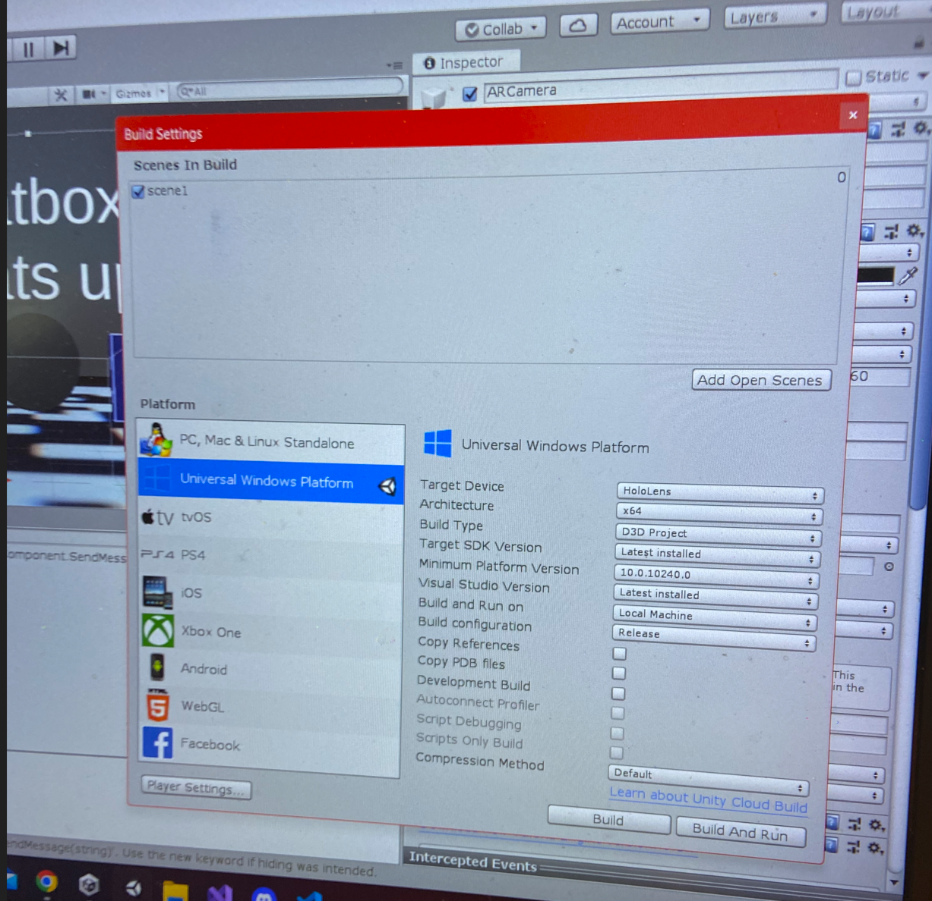

Figure 10: Unity Game Engine build settings

# 6.) Using the HoloLens Emulator for Application Launch

Note: If the user decides to use the HoloLens Emulator the configuration can vary slightly.

1. First the solution configuration setting must be changed from debug to master found on the upper left corner. That gives the user the option to run the project on the device, the HoloLens.
2. Make sure to have the HoloLens powered on and situated on head when pressing the start button on the HoloLens Emulator because the start will automatically launch the app on the HoloLens.

# 7.) Using the Application

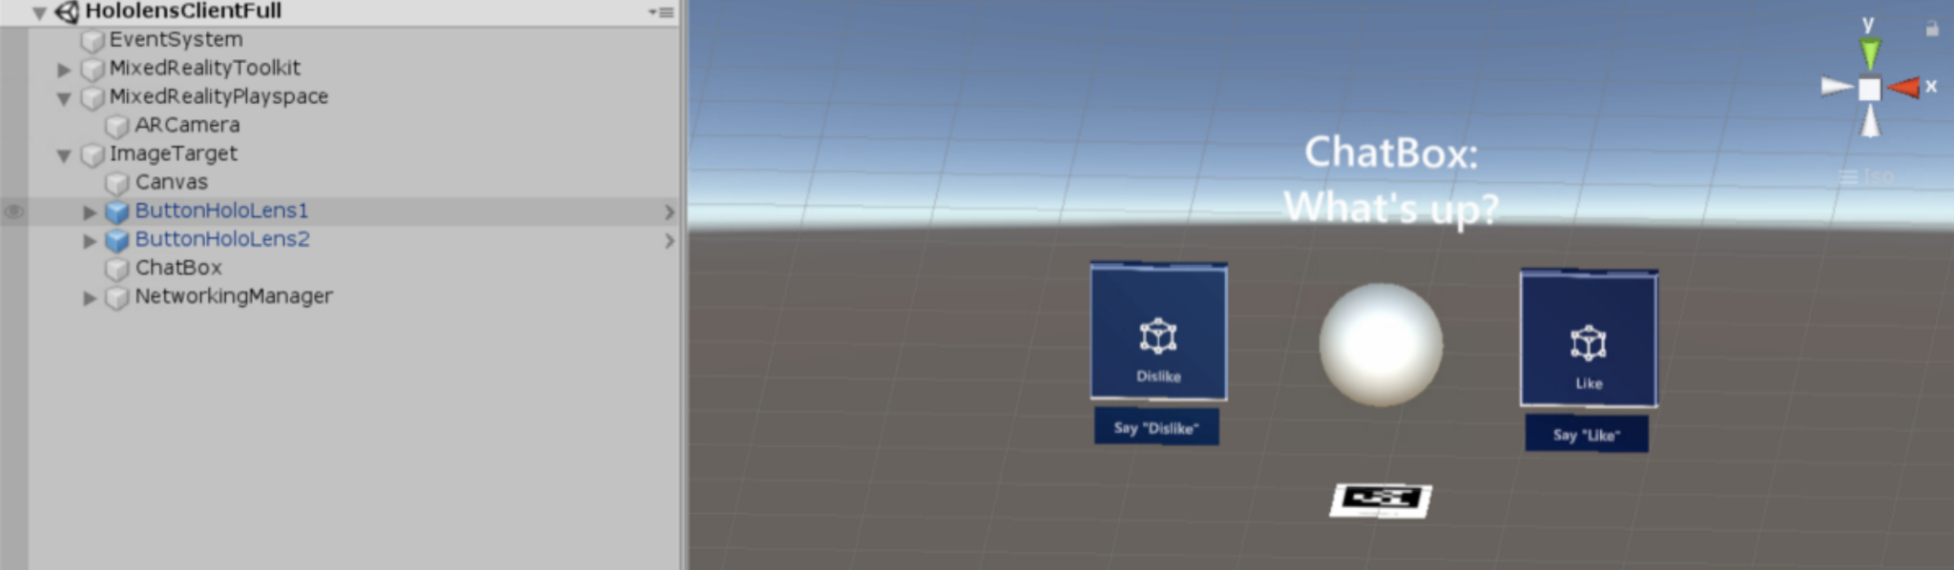

Figure: HoloLens Emulator view

1. Click on the application icon using hand held remotes.
2. Once the app launches, the HoloLens comes with a pair of hand held remotes one for each hand, the user will be able to use either remote to click on the app button to launch the game. The button will look like the buttons dislike and like in figure 9. Using the hand held remotes the user will be able to launch the app by clicking the app button.

After it is launched the user will no longer need to configure settings or click on anything. The HoloLens will interact with the user through audio events and graphical overlays but the user will no longer need to do anything until the user needs to shut down the system.

# 8.) System Shutdown

1. Power the HoloLens down. Close the Emulator by exiting the scene using the x to close down the game. The user can also use the Unity Game Engine to press the start and stop button on the top of the scene, figure 10.

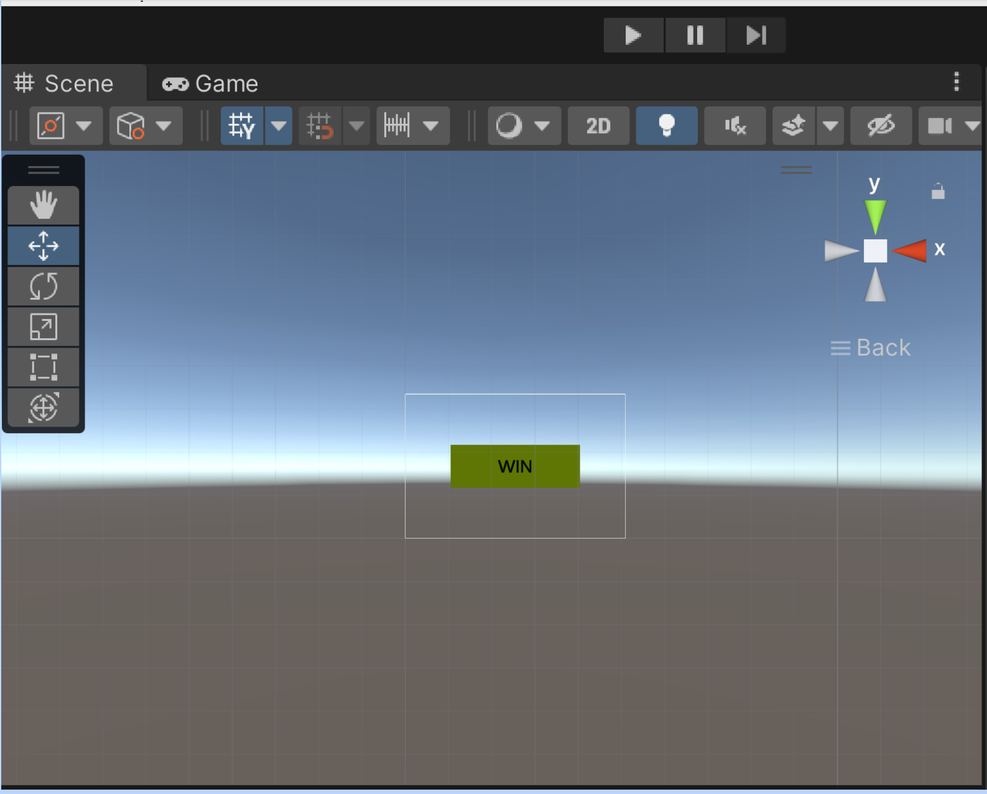

Figure 11: Unity Game Engine scene view

**Testing and Analysis Summary**

As our product has not been finished, many, if not all, of the original specifications involving the hardware performance are not met. For example, running the code solely on a server does not save power as we can not currently do that. The exception to this is the probability code, which accurately gives data on chances of winning in any given situation. The exception to this is the probability code, which accurately gives data on chances of winning in any given situation. The exception to this is the probability code, which accurately gives data on chances of winning in any given situation. The exception to this is the probability code, which accurately gives data on chances of winning in any given situation.

The exception to this is the probability code, which accurately gives data on chances of winning in any given situation. The exception to this is the probability code, which accurately gives data on chances of winning in any given situation.

See Appendix for Testing Report.

**Conclusion**

For the most part, the project completion & requirements were fulfilled. In the case of Object Detection, Unity uses a built-in package called Barracuda, a neural network interface for Machine Learning Models, ML, offering a production ready system. The team’s first choice in neural networks was to go with the built in ML in YOLO, Darknet. But because Darknet would not communicate between the YOLO algorithm and the Hololens a bridging software was necessary to make communication between these happen. The way YOLO works is that it applies a single neural network to an image then it divides it into regions all while making predictions and probabilities about detection. Once YOLO has been trained it produces a weights file that the built in neural network on YOLO, Darknet, uses for object detection. This approach makes it faster and different to the classifier-based system approach which makes the system slower. The choice to commit to Barracuda despite readily having Darknet was made because Unity had an existing plug-in for Barracuda which would make interfacing with the Hololens an easier task. YOLO still uses Darknet as its main neural network but Unity requires Barracuda.

The first issue that arose as a result of using the Barracuda software was the conversion of the weights file produced by YOLO into an Open Neural Network Exchange, ONNX, file for Barracuda. The ONNX file is an interface file type that stores the model information that Unity can read via Barracuda. This conversion would allow the loading of the Darknet trained neural network into Barracuda as an ONNX file/network. The issue was in the conversion from the weights file into an ONNX file. The ONNX file that was produced was incorrect and had issues and could not be used by Barracuda. The first meeting with Dr. Wortman tried to address these file conversion issues which mainly revolved around loading the ONNX file into Unity. Some errors were fixed, however the underlying problem was that the file was converted incorrectly. Tools to properly convert the ONNX file do not yet exist. This is an observation that was made from the team’s extensive research. Major progress was made with the investment and knowledge provided by Dr. Wortman. Unfortunately the ONNX file conversion still failed. This ultimately did not allow the team to proceed with a successful rendering of the game on the Hololens and adjustments had to be made.

To bypass not being able to render on the Hololens was the production of two different demonstrations to show the working parts of the game . A lot of effort was put into making different aspects of this project to function correctly. The only issue was the collaborative effort of trying to implement the different programs and have them work as a unit. Rendering on the Hololens was one of the main specifications for this project but due to a time constraint pursuing a resolution to this issue would not have allowed enough time to produce demonstrations for the other aspects of the project that did work correctly. Only four specifications failed to meet the status quo. Eleven out of a total of fifteen requirements were met for this project making it a 73.33% success. This was calculated using the Equation (1). Table 1 **(include section reference)** summarizes the findings on the specifications that were met and uses those findings to calculate the overall success percentage.

$Success Percentage = \frac{\# Passing Requirements \& Parameters }{\# Total Requirements \& Specifications}×100\%$ Equation (1)

In order to demonstrate the other aspects of the project working correctly two demonstrations were created. One showcases the game logic working correctly along with the special effects of audio and graphics. It hardcodes different player and dealer hands and displays the probability of those different plays in real time. Because the neural network file could not be used by unity a simple hard coded scenario was generated showing that the game logic works as it is intended too. The other showcases the trained algorithm working correctly to detect an object. This process uses the Darknet demo test program which is responsible for producing bounding boxes over objects that were successfully detected.

Once committing to the changes in the plan of execution and agreeing on the demo versions new problems arose. The user interface was not drawing the correct text for one of the probabilities. It would skip the first probability calculated, even though it obtained the correct probability and would print it on the debug console. To resolve this bug, the fix is to write to the UI text in Unity’s main thread. To use Unity’s main thread, this github repository was used:

<https://github.com/PimDeWitte/UnityMainThreadDispatcher>. Changes to the original game logic were made in order for the logic to be accessed by the main thread. Additionally for the program to work, the full path of the blackjack.py script needs to be specified in the code. So if the program tries to run on a different computer, the path most likely will need to be changed.

***Table 1:*** Result of the findings regarding the parameters and requirements set forth for the project.

| **Requirement & Parameters** | **Pass** | **Fail** |
| --- | --- | --- |
| Implemented using a HoloLens |  | x |
| Total system latency will be under two seconds |  | x |
| Improve runtime and battery life |  | x |
| Perform the app rendering and processing on a host computer |  | x |
| The AR/VR device will connect to a Wi-Fi router in order to communicate to the host computer | x |  |
| Determine if the player should hit, split, or stand for their next move | x |  |
| Determine the value of the cards held by the dealer | x |  |
| Display the probability of success for each move the player could perform | x |  |
| Display a graphic when player hits a card count of twenty-one | x |  |
| Display the statistics for next move that the player should perform | x |  |
| Play a sound when player wins the game | x |  |
| Identify the playing cards that a person is holding | x |  |
| Determine the value of the cards that are given to the player | x |  |
| Display the value of the cards that are on the table | x |  |
| Accompany a set of documents specifying every piece of software and its functionality | x |  |

These changes allowed for the project to demonstrate the majority of the working aspects of the project. Although it was done separately it still holds its 73.33% success and when training the Object Detection, we received a theoretical mean accuracy percentage, mAP, of 100% and an average loss of 0.02. In order for YOLO to function it must display a 0.25 confidence detection rating or higher and in comparison to our rating of 50% from real world tests. It significantly surpasses that rating and successfully detects accurately. Both demonstrations work properly meeting most of the passing requirements. Time constraint had a huge impact on the success percentage of the overall project but the team is confident on the progress and functionality of the project. This project can be handed down to a different group where a higher success rate can be made.

**Project Planning & Project Management**

Our team did not experience too many issues with scheduling, but we were not able to get our application to become fully operational within the amount of time we allotted for it. We experienced many issues with getting a trained Object Detection ONNX file that would work with Unity and our project. Our team planned for a month of development and another month for troubleshooting bugs. Unfortunately the allocated time was not enough and we continued to try and solve our issues right up to the end, and were still not able to get our problems resolved. Below is an overview of how our project was planned out and the different phases it went through.

**Phase 1 (Mar 4, 2022 – Apr 15, 2022):** Research was conducted on AR devices and remote rendering applications by the entire team. The entire team consulted with Dr. Omid Semiari to get the specifics of the project. William B. Micheal was contacted in order to collect the equipment that will be utilized for the duration of this project: a HoloLens One and a WiFi AX1800 Dual Band Wireless Access Point Router. The Requirements and Specification Document was written including defining team and project sponsors, the project specification intent, project requirements, parameters and target values, and the agreement to the project specification.

**Phase 2 (Apr 15, 2022 – May 6, 2022):** During Phase 2 the team worked on the Requirements and Specifications Presentation. This presentation went over the project’s problem, current standards, constraints, the requirements and specifications, the system design expectations, issues, timeline, budget, and societal concerns.

**Phase 3 (Aug 26, 2022 – Sept 12, 2022):** Phase 3 was focused on writing the Conceptual Design Report excluding the Testing Report. In this report the team has put together a decision matrix, concept recommendation, a plan to complete the design, and the testing plan.

**Phase 4 (Sep 9, 2022 – Sep 16, 2022):** The Conceptual Design Presentation will be created and given in Phase 4. This presentation will present a summary for each section of the report that was put together in the previous phase.

**Phase 5 (Sep 16, 2022 – Sep 30, 2022):** In this stage each member of the team will contribute to the Critical Design Documents including Detailed Description of Design, User Manuals, and Instructions, Detailed Drawings of parts, Schematics, Software Descriptions, Bill of Materials.

**Phase 6 (Sep 30, 2022 – Oct 7, 2022):** After finalizing the Critical Design Documents in the previous phase, our team created and practiced a presentation that showcased the important aspects of the documents.

**Phase 7 (Oct 8, 2022 – Nov 21, 2022):** Although the team had been working on the actual design of the project since May, in this phase the team solely focused on completing the AR Blackjack Assistant Remote Rendering Application which also incorporated the application’s testing.

**Phase 8 (Nov 6, 2022 – Dec 7, 2022):** In this part of the project the team finished the Conceptual Design Documents by writing the Testing Report. This summarized the testing that was completed at the end of Phase 6. During this timeframe, the team also concluded that object detection integration was no longer a feasible option due to a time constraint.

**Phase 9 (Nov 21, 2022 - Nov 27, 2022):** Phase 9 is where our team concentrated on writing this report, the Final Report. This report includes an Executive Summary, an Introduction, a Problem Description, a Conceptual Design, a Finalized Design, a Testing Analysis Summary, a Conclusion, and the Final Design Package.

**Phase 10 (Nov 28, 2022 - Dec 9, 2022):** A final presentation will be developed and given discussing the project, problem, conceptual design, finalized design, and the testing and analysis.

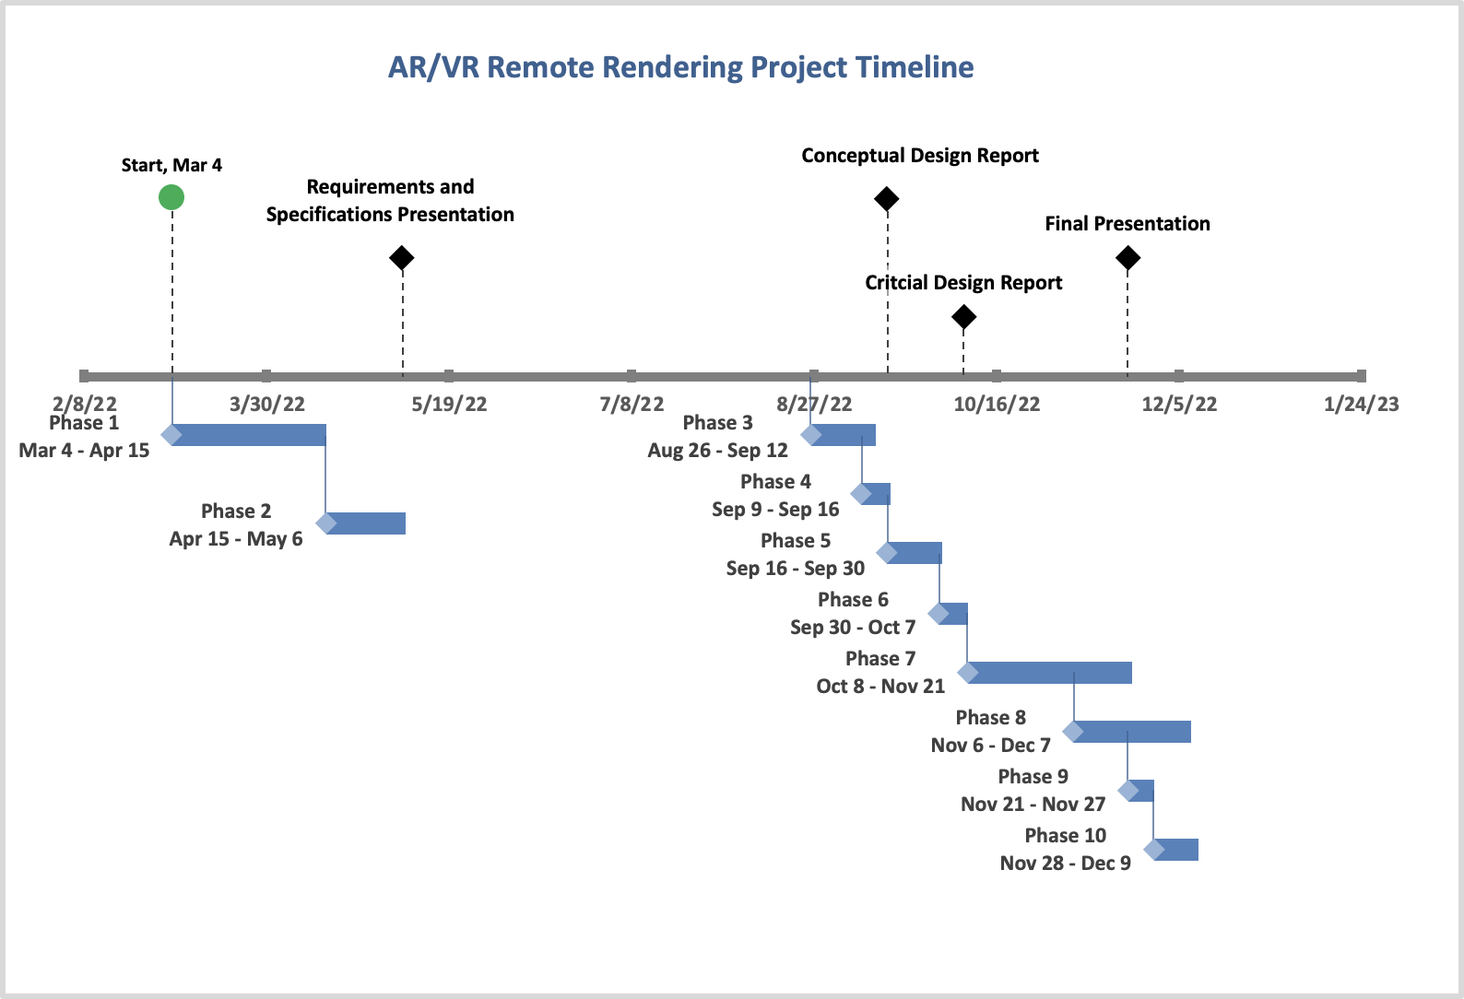

See Appendix for Gantt Chart

**Sponsor Interations**

In the beginning, our team did struggle with getting in contact with our sponsor Dr. Omid Semiari. It was difficult to get a response from him by email and we only had one video conference meeting with him. In the team’s video meeting we asked as many questions that we could think of and got as much information as possible in order to not have to worry about the limited contact that we were receiving. After getting our new sponsor Dr. Dana Wortman we did not experience any difficulties with contact and not being able to meet. We remained in regular contact via email and when we started running into issues with our Object Detection integration. To resolve this issue we met through Teams to troubleshoot software bugs as a team. Dr. Wortman has been extremely helpful. Her background as a software developer in Unity has really enabled the team’s efforts by providing a confidence to engage and resolve unknown issues in Unity. Her knowledge and involvement were well received and her dedication to the team demonstrated leadership that was thoughtful and caring. The team benefited from these qualities because it uplifted morale. A shift with sponsor relations was accomplished with Dr. Wortman’s involvement. It changed from one that lacked effective communication and general assumption of the sponsor role to one that filled the need in the most effective way possible.

**Team Interactions**

Communication between team members throughout the duration of the project was done efficiently and effectively. Our main source of communication was done in our Discord channel and it was there where we discussed problems, things we were able to accomplish, and any questions that group members had. As a team we also met every Tuesday at 4:30 to work on our application, go over reports, and practice presentations. Lastly, we would meet every Friday to go over tasks, statuses, and issues that we faced since our previous meeting. Overall, our team worked really well together and we were all very committed to the success of our mission.

**Team GitHub Link**

<https://github.com/uccsAR-VR/AR-Annihilators>

**Resources**

1. geaxgx and dsousadev, "GitHub," 2019. [Online]. Available: https://github.com/geaxgx/playing-card-detection.
2. AlexeyAB and pjreddie, "GitHub," 2021. [Online]. Available: https://github.com/AlexeyAB/darknet.
3. wojciechp6, "GitHub," 2020. [Online]. Available: https://github.com/wojciechp6/YOLO-UnityBarracuda.
4. wiibrew, 2017. [Online]. Available: https://github.com/wiibrew/pytorch-yolo2.
5. keijiro, "GitHub," 2021. [Online]. Available: https://github.com/keijiro/YoloV4TinyBarracuda.
6. Tianxiaomo, "GitHub," 2020. [Online]. Available: https://github.com/Tianxiaomo/pytorch-YOLOv4.
7. “Aka.ms.” [Online]. Available: https://aka.ms/CPUProfileforDevicePortal. [Accessed: 2022].
8. PimDeWitte, “Pimdewitte/UnityMainThreadDispatcher: A simple, thread-safe way of executing actions (such as Ui Manipulations) on the Unity Main Thread,” *GitHub*. [Online]. Available: https://github.com/PimDeWitte/UnityMainThreadDispatcher. [Accessed: Dec-2022].
9. “Textmesh Pro - Textmesh Pro is not updating when changing text programatically,” *Unity Forum*. [Online]. Available: https://forum.unity.com/threads/textmesh-pro-is-not-updating-when-changing-text-programatically.490125/page-2. [Accessed: 2022].
10. Windows-Driver-Content, “Windows performance analyzer step-by-step guide,” *Microsoft Learn*. [Online]. Available: https://docs.microsoft.com/en-us/windows-hardware/test/wpt/wpa-step-by-step-guide. [Accessed: 2022].

**Appendix**

Figure 1: Testing Report

TEST REPORT

**Introduction**

The test plan is a verification process that demonstrates the software and hardware features of the AR/VR device functioning correctly. The test plan is written to outline the steps that are necessary to produce a high-quality product that meets all requirements listed on the specification sheet. The AR/VR device testing will accomplish verification of successful connection to the Wi-fi router. Testing a solid connection to the router will allow the device to connect to the host computer for processing with the app. All these tests will allow observations on the battery life of the device. Our projections are that having a host computer process will allow battery life improvement.

Another aspect of testing is also attributed to the user and their interaction with the final product. Once the hardware and software have been fully assessed, user interaction is something that will need to be tested to fulfill the project's overall mission. This test plan will allow the team to study and gather data on the operations of the system in individual components and as a whole.

**Methodology and Procedure**

**Methodology**

This AR remote rendering application will be tested utilizing the Hololens 1, Wi-Fi, a computer, and a bench-mark app (non-remote rendering).

As a team we were unable to achieve full integration with the object detection and unity application. Therefore, we were only able to conduct a test for each class separately, as well as testing all the classes combined within Unity minus the Object Detection input.

**Procedure**

**Testing Classes individually**

GameLogic

1. Create two variables, one for the total card count for the player and one for the dealer.
2. Change the variables so that you can test each possible outcome.
   * + Settings
       1. Surrender - Player hand = 0, Dealer hand = Any
       2. Player Busts - Player hand > 21, Dealer hand = Any
       3. Continue Playing - Player hand = Any, Dealer hand <= 16
       4. Player Wins - Player hand > Dealer hand, Dealer hand != 16 or Dealer hand > 21 and Dealer != 16
       5. Dealer Wins - Dealer hand > Play hand and Dealer hand != 22
       6. Push - Player hand = Dealer hand

Blackjack (probability)

* + Launch a Jupyter notebook
    - Open your terminal and navigate to the directory where you would like to save your notebook.
      1. Type the command jupyter notebook, the program will instantiate a local server at localhost: 8888 (or another specified port)
      2. A browser window should immediately pop up with the Jupyter Notebook interface, otherwise, you can use the address it gives you.
    - Create a new notebook
      1. Go to New and select the Notebook you’d like to use or Click Upload a Notebook you want to use.
      2. Notebooks currently running will have a green icon, while non-running ones will be gray. To find all currently running notebooks, click on the Running tab to see the list.
    - Run Cells
      1. Cells are how notebooks are structured and are the areas where you write your code.
      2. To run a piece of code, click on the cell to select it, then press SHIFT+ENTER or press the play button in the toolbar or you can utilize the Cell dropdown menu which has several options to run cells.
    - After a Cells are ran
      1. The output of the cell’s code will appear below it. To stop running a piece of code, press the stop button.
    - Example run
      1. In [1]: Entire blackjack class
      2. In [2]: game = blackjack()
      3. In [3]: game.newhand(shuffleafterhand=True)
      4. In [4]: game.cardplayed((9,1)) # Dealer gets 9

game.cardplayed((12,0)) # User gets Q

game.cardplayed((9,1)) # Dealer gets 9

Output:

Stand Probability = 22.0%

Hit Probability = 44.72%

Split? None

* + - 1. In [6]: game.cardplayed((12,0)) # User gets Q
      2. In [7]: game.getmoves()

game.printprobs()

Output:

Stand Probability = 87.95%

Hit Probability = 33.25%

Split? False

* + - 1. In [8]: game.newhand(shuffleafterhand=True)
      2. In [9]: game.cardplayed((9,1)) # Dealer gets 9

game.cardplayed((14, 0)) # User gets A

game.cardplayed((6,1)) # Dealer gets 6

game.cardplayed((14,0)) # User gets A

* + - 1. In [10]: game.getmoves()

game.printprobs()

Output:

Stand Probability = 80.72%

Hit Probability = 37.68%

Split? False

* + - 1. In [11]: for j in range(2,10):

for i in range(3):

game.cardplayed((j,2)) # extra tests

* + - 1. In[12]: game.getmoves()

game.printprobs()

Output:

Stand Probability = 41.83%

Hit Probability = 61.05%

Split? True

Object Detection

Currently, the detection works via a webcam & the built-in darknet detector demo [2]. This demo runs interference on the input webcam frames, and then draws bounding boxes on the output video feed frames. Prerequisites for the demo:

* Darknet [2] must be compiled.
* A trained weights file must be generated.
* A webcam is preferred but the detection does work on static images.

To run the demo:

1. Plug in the webcam into the host computer.
2. Position the webcam vertically above the cards to be detected and make sure the scene has plenty of light.
3. Navigate to the darknet folder containing the build files.
4. Run the following command from windows PowerShell:

**darknet** detector demo .\data\obj.data .\cfg\yolov4-tiny-obj3.cfg .\backup\yolov4-tiny-obj3_20000.weights -c 0

**.\data\obj.data** → location of the custom object data file.

**.\cfg\yolov4-tiny-obj3.cfg** → location of the custom object configuration file.

**.\backup\yolov4-tiny-obj3_20000.weights** → location of the trained WEIGHTS file.

**-c 0** → Use system webcam with ID=0

1. Observe the output in the video feed window with the bounding boxes drawn on. The identified cards will also appear in the command line window.

Testing Unity Project

In this section we will be testing all the classes together within Unity without the Object Detection input.

1. Within the Start function of the GameLogic class contained in the Unity project, change the values that are added to the argumentList. Use values that will give you each possible outcome.

Note: The values added after “p” will be added together to get the Player’s hand and every value after “d” will be added together to get the Dealer’s hand.

Settings

* + - Surrender - Player hand = 0, Dealer hand = Any
    - Player Busts - Player hand > 21, Dealer hand = Any
    - Continue Playing - Player hand = Any, Dealer hand <= 16
    - Player Wins - Player hand > Dealer hand, Dealer hand != 16 or Dealer hand > 21 and Dealer != 16
    - Dealer Wins - Dealer hand > Play hand and Dealer hand != 22
    - Push - Player hand = Dealer hand
  + After the changes have been made and saved in the GameLogic class. Run the Unity project by pressing the play button at the top middle of the screen.

Full System

**Setting up HoloLens to use Windows Device Portal**

1. Power on your HoloLens and on the device.
2. Use the Bloom on HoloLens to launch the main menu.
3. Gaze at the Settings tile and do an air-tap gesture on HoloLens.
4. Select the Update menu item.
5. Select the For developers menu item.
6. Enable Developer Mode.
7. Scroll down and enable Device Portal.
8. Set up the Windows Device Portal so you can deploy apps to this HoloLens over Wi-Fi, select Pair to generate a pairing PIN. Leave the Settings app at the PIN popup until you enter the PIN into Visual Studio during your first deployment.

**Connecting over Wi-Fi**

1. Connect your HoloLens to Wi-Fi.
2. Look up your device’s IP address by either:
   1. Going to Settings > Network & Internet > Wi-Fi > Advanced Options.
   2. Going to Settings > Network & Internet and selecting Hardware properties.
   3. Using the “What’s my IP address?” voice command.
3. From a web browser on you PC, go to https://<YOUR_HOLOLENS_IP_ADDRESS>
   1. The browser will display the following message: “There’s a problem with the website’s security certificate” because the certificate, which is issued to the Device Portal, is a test certificate. You can ignore this certificate error for now and continue.

**Installing a certificate**

1. In Windows Device Portal, navigate to the Apps manager page.
2. In the Deploy apps section, select Install Certificate.
3. Under Select certificate file (.cer) used to sign an app package, select Choose File and browse to the certificate associated with the app package that you want to sideload
4. Select Install to start the installation.

**Installing the benchmark/non-remote rendering application**

1. When you’ve created an app package from Visual Studio, you can remotely install it onto your device from the generated files.
2. In Windows Device Portal, navigate to the Apps manager page.
3. In the Deploy apps section, select Local Storage.
4. Under Select the application package, select Choose File and browse to the app package that you want to sideload.
5. Check the respective boxes if you want to install optional or framework packages along with the app installation and select Next.
6. Select Install to start the installation.
7. Once the installation is complete, go back to the All apps page on your HoloLens and launch your newly installed application.

**Instantaneous System Performance Readings**

1. From the Windows Device Portal home page on the Microsoft HoloLens, Select the Views from the menu on the left.
2. Then select Apps.
   1. Ensure that the only app that is currently running is the one being tested.
   2. End any unnecessary processes that are running.
3. From the Windows Device Portal home page on the Microsoft HoloLens, Select the Performance from the menu on the left.
4. To see the instantaneous system performance, select System Performance.
   1. Log the following metrics periodically during the test:
      1. **SoC power:** Instantaneous system-on-chip power usage, averaged over one minute
      2. **System power:** Instantaneous system power usage, averaged over one minute
      3. **Frame rate:** Frames per second, missed VBlanks per second, and consecutive missed VBlanks
      4. **GPU:** GPU engine usage, percent of total available
      5. **CPU:** percent of total available
      6. **Memory:** Total, in use, committed, paged, and non-paged

**Performing a trace**

1. On the left, navigate to Performance > Performance Tracing
2. Choose an available profile or select Custom profiles > Browse then use this profile to analyze CPU performance:

<https://aka.ms/CPUProfileforDevicePortal>

1. Click Start Trace.
2. The HoloLens is now recording a trace. Make sure to trigger the performance issues that you want to investigate, and then select Stop Trace.
3. The trace will be listed at the bottom of the webpage. Select the disk icon at the right-hand side to download the ETL file.

You now have an ETL file that you can either open directly in WPA or send to someone else.

**Results and Analysis**

Object Detection

For testing of object detection, we can use metrics from training, as when training the current dataset, we use mAP (mean Average Precision) which describes the perceived accuracy of training by comparing the training dataset to the validation dataset. We also use average loss or error. See the plot below. Ideally, we want a high mAP (accuracy) and a low error. For around the 20,000 iterations we trained for, the below graph is shown of the mAP and avg loss. From the graph, you can see the avg loss ended up being 0.117 & mAP = 100%. We believe that the stopping point chosen, defined as “early stopping point”, can be more accurate than training for 40,000+ iterations.

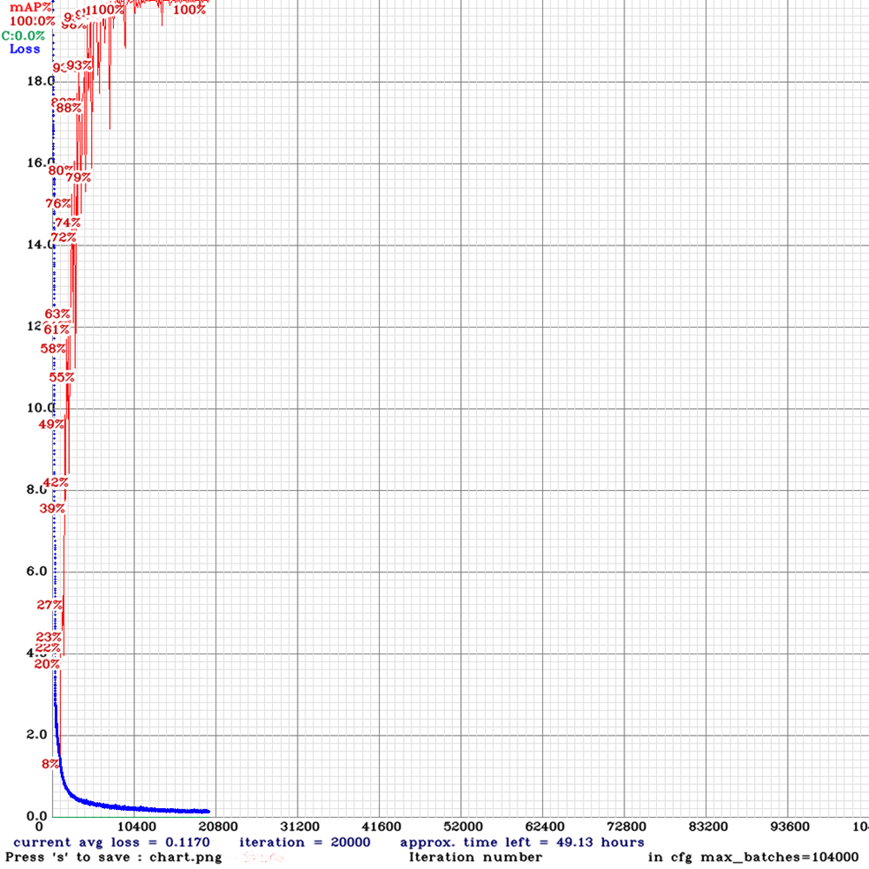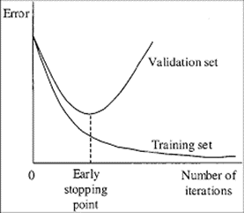

Probability Algorithm

While designing the probability algorithm, a jupyter notebook was created to both demonstrate how to use the class, and test that it works as intended. A jupyter notebook is a feature of python that allows you to run code in ‘cells’, while a kernel runs in the background. The first cell is very long, so it will not be detailed here, but it defines the blackjack class that is used to perform all the necessary calculations.

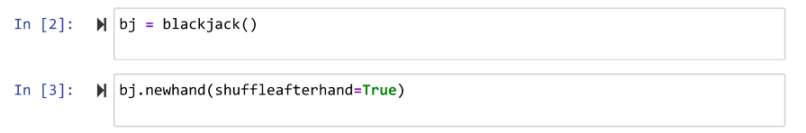

In cells 2 and 3, the class is instantiated, and a game is begun by setting up a new hand.

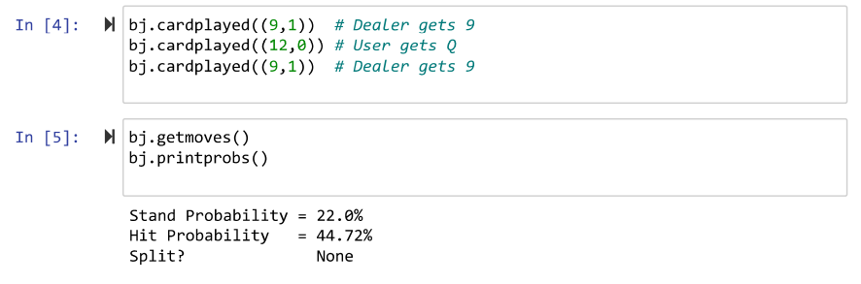

In cell 4, three cards are played, two for the dealer, and one for the user. In cell 5, getmoves is called to do the calculations, and printprobs is called to print them out, as shown.



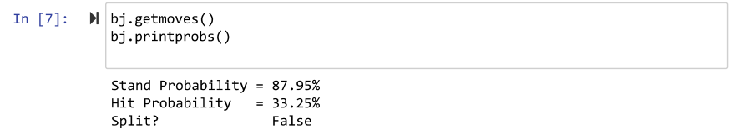

In cell 6, another card is played, and in cell 7, the probabilities are reprinted to show that they have changed as a result of a card being played.

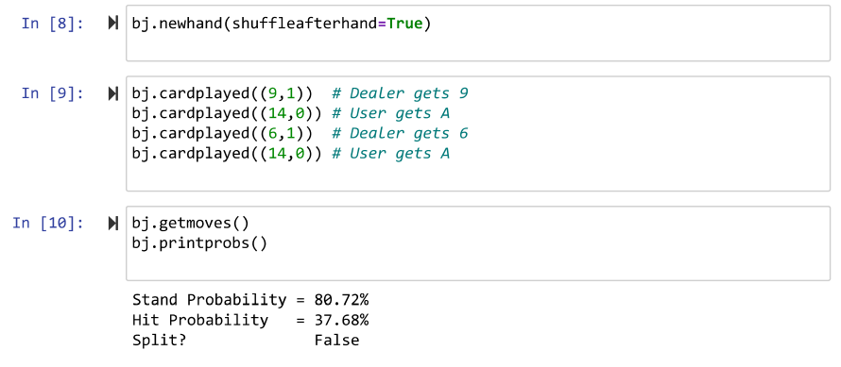

Cells 8, 9, and 10 are similar, but the cards played demonstrate the program deciding whether or not the user should split.

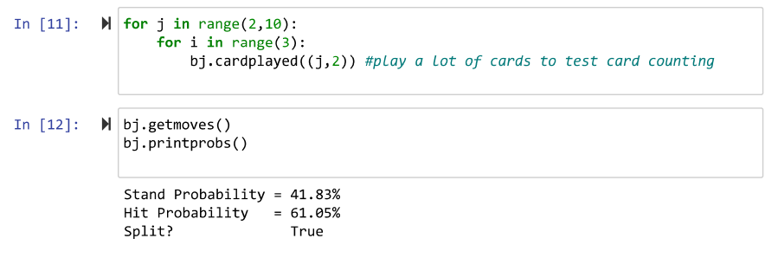

Cells 11 and 12 continue on to show that by changing the cards in the deck, by playing cards to neither the dealer or user, the probabilities are changed so much that splitting becomes the correct choice, where it was not before.

User Interface

To test the UI, after building the UI solution in the “GameLogic.cs” C# script, the Unity Engine Debug Console was used to print out the probability values to determine that the UI is working correctly. Once it was built correctly, it would print out the values in the UI in yellow text, the “Stay” probability, and the “Hit” probability for the player. This testing using the debug console helped find a solution to a bug that was experienced in the design process. This bug was that it would not display the first probability on the UI text: “TextMeshPro - Text” object, even though it recognized the correct probability when printing it to the debug console. Ultimately the fix to the bug has been found after looking at a forum: "<https://forum.unity.com/threads/textmesh-pro-is-not-updating-when-changing-text-programatically.490125/page-2>”, it mentioned that running the needed code in the main thread of Unity Engine would fix it. To run the Unity Main thread, we used this Github repository which was linked to the forum found: “<https://github.com/PimDeWitte/UnityMainThreadDispatcher>”.

Overall, the debug console has been crucial for performing constant tests during the development of the UI for the blackjack assist app. It was constantly used to verify that variables and data structures are correct, as well as the logic for the app. For example, the global list: “argumentList” was iterated and printed to show it has the correct values. It has single character strings inside the list which represent the hands for the player and for the dealer. It has “p”, and “d” to denote dealer and player, and then the following card values are specified for player and dealer. This list is used to build the command line command with command line inputs when executing the blackjack.py python script with command prompt.

The following photo shows the debug console, it can be seen it prints the probabilities obtained from the “blackjack.py” file, and as well as single numbers which are from the global list, “argumentList” values. The probabilities seen in the photo are 21.35%, and 43.6%, they don’t have the percentage sign in the debug console, but they are the probabilities for that round of blackjack. Additionally, a notification from the debug console can be seen from the picture, it mentions who is the winner for that round of blackjack.

As a result, the testing performed on the user interface (UI) showed the correct behavior, and displayed the correct probability values obtained from the probability algorithm in the python blackjack script “blackjack.py”. The correct probabilities obtained from “blackjack.py” are reflected in the actual UI when starting the app, as well as on the debug console. Other tests performed, specifically executing the python script on command prompt with command line arguments, a text file was written to show the correct command line argument values has been received successfully from the “GameLogic.cs” C# script. Other successful tests performed include printing to the debug console who is the winner for that round of blackjack, the player, or the dealer. Testing to check that the global lists had the correct values from the set values for the player and dealer hands has been tested using the debug console, and is working correctly.

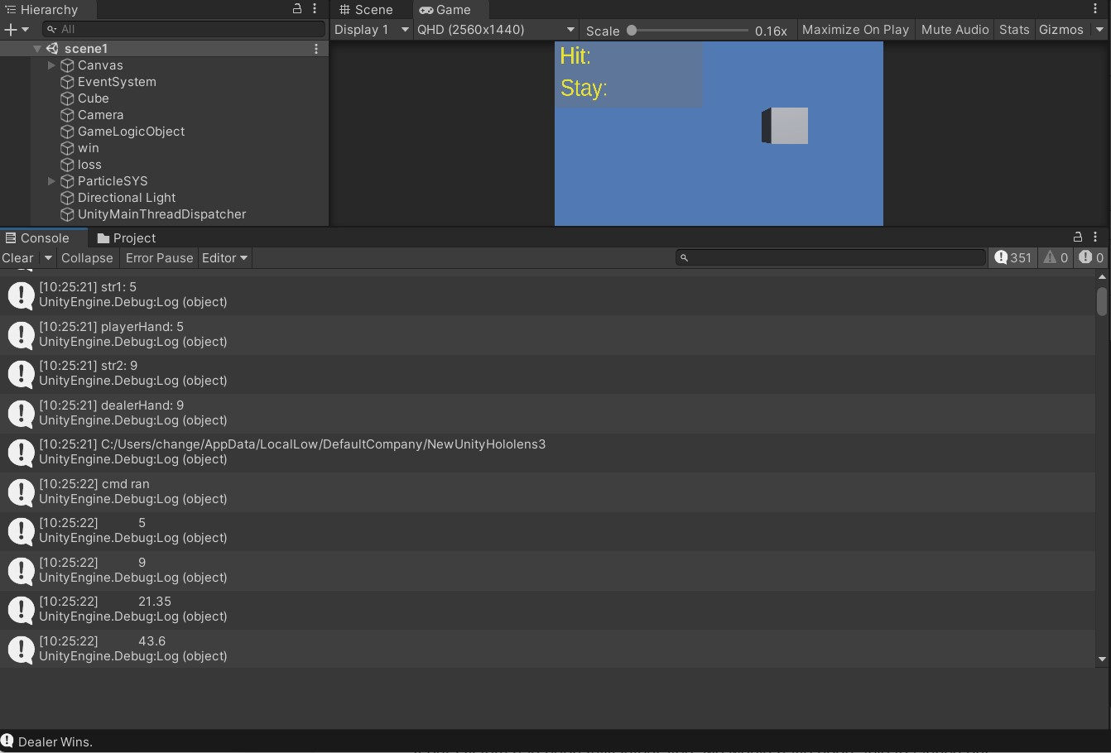

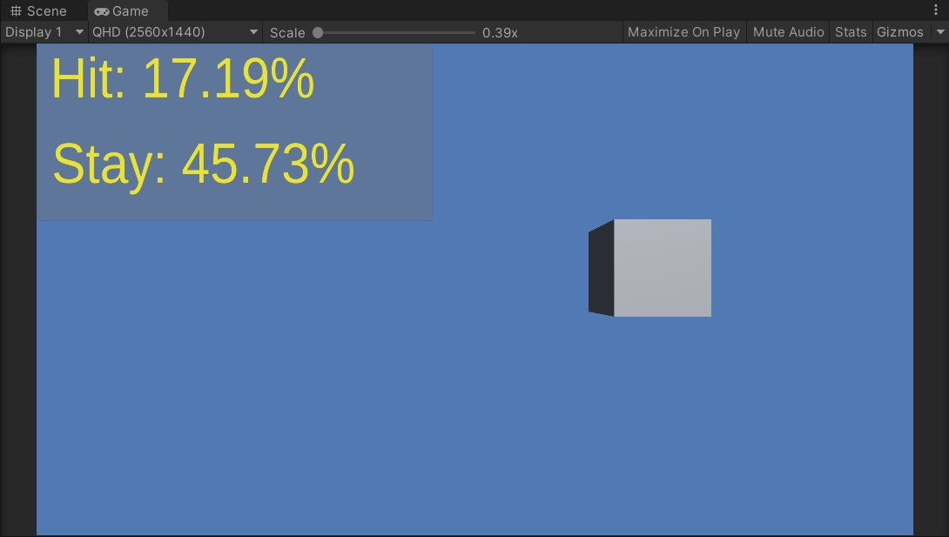

Special Effects

Blender is the free and open source 3D creation suite. It supports the entirety of the 3D pipeline—modeling, rigging, animation, simulation, rendering, compositing and motion tracking, even video editing and game creation. The coin was created manually using this software and otherwise would not be available as a special effect. The coin design was used following an online tutorial because Blender use was unknown.

For a raining coin effect in Unity the created 3D graphic had to become an object with components that included a particle system which would allow the new 3D import to have moving capabilities such as rotation and dispersion. Providing a Rigidbody component In Unity allowed these 3D coins to have physics qualities like the effect of gravity on falling objects which was a desired effect for this graphic.

Testing the raining coins effect included exporting the FBX file into Unity. This file contained the lighting, 3D object dimensions, and the customized gold color created on Blender. Once the 3D graphic was in Unity there were many adjustments and settings that were changed to view the coin design in a new platform such as Unity. The color did not transfer well from software to software therefore a new custom gold color was created in Unity and added to the 3D graphic. The dimensions of the coin also did not automatically stranger over and adjustments in Unity allowed the coin to become 3D once in Unity.

To have more control of this new particle system in Unity the team wanted to include a script that would allow the particle system to just be called and seen when necessary. Having too many objects in every frame of the game takes up a lot of memory and can cause delays or even GPU crashes. Aside from that the team just wanted the coins to be shown whenever the player won the game. Without implementing the particle system to the other parts of the game to include the game logic to include this control aspect a switch was created using the keyboard as an input for turning the switch ON and OFF. This will change as testing progresses for this system.

Unity is a powerful and diverse platform that gives creators and designers the power to be creative by providing many resources to allow special effects to take place like sound and custom moves. Sound effects can be made possible as imports while customizing the moves of an object in the game can be made possible through a script file. For the raining coins to have a sound effect associated with them there was a WAV file uploaded with a jackpot sound from a casino. Attaching the file as an audio clip in an audio source, a component of the object, allowed this effect to take place.

The combination of these was not terrible to test because they worked as they were intended to. Once implementing them into the game logic is where sound failure was experienced. There was sound so it wasn't an absolute failure it just no longer sounded like hitting a jackpot. This caused the elimination of this sound effect from the winning special effects and only the raining of coins stayed. The losing sound effect stayed because it worked correctly.

Full System

If our system had been fully integrated, we would have been able to launch our application on the Microsoft HoloLens. Once the application was launched, we would have been able to perform a trace from the Windows Device Portal. After the trace finished, an ETL file would have been available to download. An ETL file can be opened directly in the Windows Performance Analyzer, which is a tool that would have allowed us to visualize the traces as graphs and tables that show the system and application performance. The following data could have been collected from the WPA software:

1. SoC power: System-on-chip power usage
2. System power: System power usage
3. Frame rate: Frames per second, missed VBlanks per second, and consecutive missed VBlanks
4. GPU: GPU engine usage, percent of total available
5. CPU: percent of total available
6. Memory: Total, in use, committed, paged, and non-paged

This information would have been used to compare the application running on both the headset and on the host computer. By doing this our team would be able to prove that by utilizing a host computer would indeed increase the battery life and performance of the HoloLens.

**Discussion**

Object Detection

For Object Detection, Ideally, we would like to test the results in the real world with the object detection algorithm attached to the hololens & camera, but since we were unable to achieve that goal, we ended up testing each component separately. The results are of course with a camera at a 90° angle above the cards. If the tests were to be done on the lens, the angle would likely be around 135°, which produced a much lower mean average accuracy.

Probability Algorithm

As for the testing of the probability algorithm, the testing was not as rigorous as it perhaps should have been, but served the purpose of making sure the code would operate as expected with other parts of the project. In the test notebook, provided are a few examples of using the algorithm, during which a few of the features of the algorithm are showcased. This does seem to show that the algorithm is working as expected, as the results make sense given the inputs. However, If we were to do these tests with more depth, it would be reasonable to demonstrate each characteristic individually, then mix a few together, so as to test each piece more completely.

User Interface

The user interface (UI) test results were promising. After building the solution to the game logic using “GameLogic.cs” C# script, the script was able to successfully communicate with the “blackjack.py” python probability script. This was seen after the python script writes to a text file the probabilities obtained from “GameLogic.cs” via command line input arguments. In addition, it correctly displays who is the winner for that round of blackjack in the debug console.

Moreover, using the debug console, and researching online, bugs have been fixed. For example, the bug where it skipped printing the first probability to the UI, the Unity Main Thread Dispatcher github repository fixed that bug. Other bugs like when building the global list having incorrect string values have been fixed thanks to the testing performed using the debug console. One more bug that was fixed with testing using the debug console, was when the python script was not being executed after writing the build command string to the command prompt. It turns out that it had to be in the directory where “blackjack.py” was first, and then running “python blackjack.py” works for executing the python script. This meant the code was changed so that two commands were written to the command prompt for these purposes.

Full System

The following data would have been collected and analyzed if our project had been fully integrated:

**Data collected**

1. SoC power: System-on-chip power usage
2. System power: System power usage
3. Frame rate: Frames per second, missed VBlanks per second, and consecutive missed VBlanks
4. GPU: GPU engine usage, percent of total available
5. CPU: percent of total available
6. Memory: Total, in use, committed, paged, and non-paged

**Reason data this collected**

1. SoC power and System power - collected to view how much power is being used while each app is being used
2. Frame rate - collected to view how fast the communication is between each app and the hololens
3. GPU, CPU, Memory usage - collected to see how efficiency of the application

This information would have been used to compare the application running on both the headset and on the host computer. By doing this our team would be able to prove that by utilizing a host computer would indeed increase the battery life and performance of the HoloLens.

**Conclusions**

From our testing, we've learned many lessons about designing a product, mostly on the developmental side. Most of this involves finding bugs in code, as have been the bulk of our problems.

Testing for us was a means of seeing if our product was working at all, and as such, we did not rigorously test multiple aspects of our product. An improvement on this process would be a more thoughtful approach to testing, so that more erroneous errors could be caught earlier.

Testing for the actual Microsoft Hololens battery performance, and the latency of the app with respect to the Hololens was not implemented due to not being able to successfully integrate the hololens to the final product. Other than that, the testing for the written code has been performed and helped fix bugs and made sure the correct results have been obtained.

Bugs that have been fixed thanks to testing include the bug where it skipped the first probability when printing to the UI. Moreover, it helped fix a bug where the correct values for player and dealer’s hand was not being obtained in the global list “argumentList”, which was important for writing the correct command to the command prompt process to obtain the probabilities from the python probability algorithm “blackjack.py”. The bug where it wasn’t executing the python script via the command prompt was fixed.

All-in-all I’d say there are a few things we could have done differently next time had we known all the knowledge gained from the project. We would: (1) take pictures at the ideal 135° angle, (2) train the dataset on the ideal 135° angle. This would provide much more accurate results since the basis of the data will be at the angle the hololens sees the project at. However, since we did not get this running on the lens, the angle of 90° worked well enough for our tests.

Figure 2: Gantt Chart

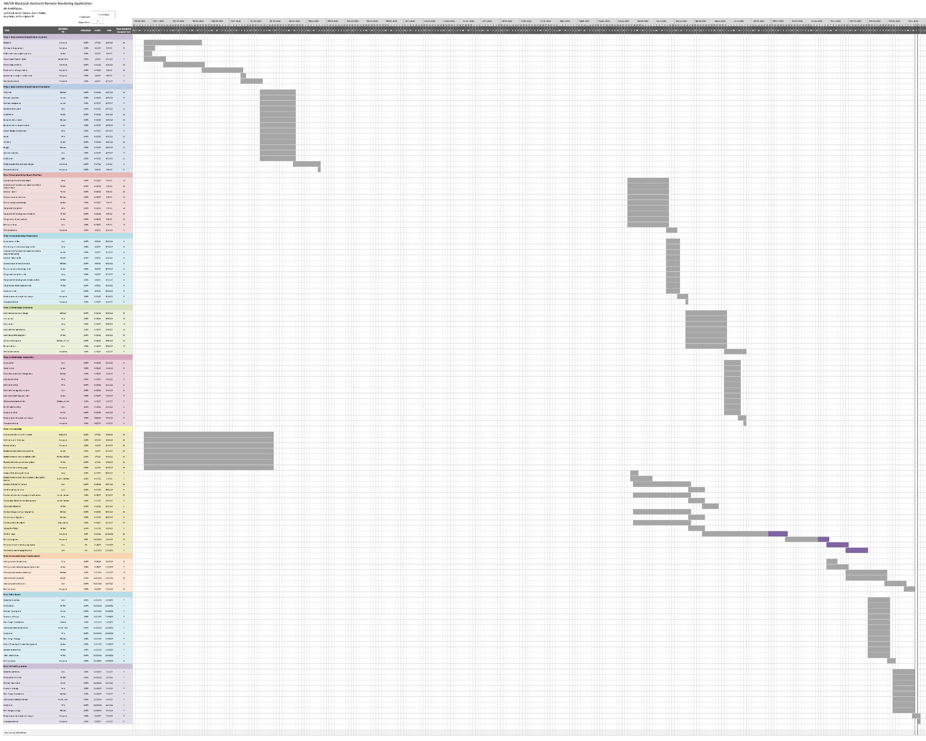

1. Input an image into the neural network and receive an output.
2. An open-source machine learning framework that interfaces between a neural network and your system’s GPU (Graphics Processing Unit).